Some Fish Species Showing Commensalism Traits with Long-spined Sea Urchin (Diadema setosum Leske, 1778) in Gulf of Antalya
Ferhat ÇAĞILTAY¹⁾, Mehmet GÖKOĞLU²⁾, Ramazan YILMAZ³⁾, Alper YILDIZ²⁾

¹ Istanbul University, Faculty of Aquatic Sciences, Istanbul, Turkey
²Akdeniz University, Faculty of Fisheries Antalya, Turkey
³Akdeniz University, Health Services Vocational School, Antalya, Turkey

Corresponding author: Ferhat CAGILTAY; ferfez@istanbul.edu.tr

ABSTRACT
This research was carried out with a rocky (Cliffs: 36.53313⁰ N; 30.414978 ⁰E) stony and gravelly bottom (Konyaaltı beach: 36.53007 ⁰N; 30.404336 ⁰E) in two different regions of Gulf of Antalya. In this study, it was intended to determine the fish species that use the long-spined sea urchin (Diadema setosum Leske, 1778) as a shelter. In the study, the fish that use the sea urchin in the rocky area as a shelter area Chromis chromis, Cheilodipterus novemstriatus, Thalassoma pavo, Coris julis, Tripterygion melanurum, Gobius bucchichi. Of these species, only C. novemstriatus is exotic. Others are native species of the Mediterranean. C. chromis juveniles were the most dense among the sea urchin spines in the rocky region, while C. novemstriatus formed the second crowded species.
In the study carried out in the second area, which has a stony and gravelly bottom structure, fish species that use sea urchins as shelter are C. novemstriatus, Siganus rivulatus, Apogonichthyoides pharaonis, Pteragogus pelycus, Parupeneus forsskali, Pterois miles, Sargocentron rubrum, Epinephelus aeneus and C. julis. Of these species, only E. aeneus and C. julis were determined to be native species of the Mediterranean. All of the other species are Red Sea species, with Rabbitfish (S. rivulatus) fry as the most dense species, C. novemstriatus in the second place and A. pharaonis in the third place are.
It was determined that adult and juvenile individuals of C. novemstriatus, A. pharaonis and P. pelycus used sea urchin as shelter, and only juveniles of other species. In addition, among the sea urchin spines, most of the C. novemstriatus, A. pharaonis individuals were found to carry eggs in their mouths.
According to the findings obtained in this study, it can be said that the long-spined sea urchin, which increases its population rapidly in the Mediterranean, also contributes to the increase in their population in the Mediterranean by creating a shelter for some fish species of Red Sea origin that cannot be economically evaluated and invaded.
Keywords: Long-spined Sea Urchin; Diadema setosum; Commensalism; Gulf of Antalya

INTRODUCTION
The long-spined sea urchin D. setosum is a Lessepsian echinoderm species that migrated from the Red Sea to the Mediterranean. Yokes & Galil (2006) made the first record of this species in the Mediterranean on the shores of the Kaş peninsula. One year after this record, the second record of the species from the Mediterranean was found by Gökoglu et al., (2007) from Antalya-Konyaaltı beach cliff region. After these notifications, the species rapidly expanded its distribution in the Mediterranean and Notifications have also started to be given from the Aegean Sea (Pirkenseer, 2020). D. setosum by many researchers has been reported as follows; Along the Lebanese coastline (Nader & Indary 2011), the Levantine Basin from the Israeli coast (Bronstein & Kroh 2018), the southeast coastline of Turkey (Turan et al., 2011), the Aegean Sea (Yapici et al., 2014) and from Rhodes Island (Kondylatos & Corsini-Foka, 2015). This sea urchin expanded its distribution to the north on the Turkish coasts and entered the Sea of ​​Marmara (Artüz & Artüz, 2019). The rapid distribution of the species and the rapid increase in its population in the regions where it was registered are indicators that it is very well adapted to the Mediterranean ecosystem.
The long-spined sea urchin is a species of echinoderm with venomous spines (Yokes & Galil, 2006; Gökoglu et al., 2007). It is shown among the dangerous species in the Mediterranean as it can cause various injuries and poisonings in humans. Its excessive proliferation on the shores of the Mediterranean and Aegean Seas and its emergence into shallow waters on the shores pose a risk of injury and poisoning for those entering the sea.
Migration from the Red Sea to the Mediterranean is not limited to sea urchins. There are many organisms that migrate from the Red Sea to the Mediterranean (Zenetos, 2019). Fish are also among the migratory species. Various researchers have reported that more than 100 Red Sea origin fish species have crossed into the Mediterranean until now (Golani, 2021). On the coasts of Turkey, this number has approached about 100. The number of Red Sea origin fish species are reached about 67 in Gulf of Antalya. The last reported fish species was Epinephelus fasciatus, also called Red grouper (Gökoglu et al., 2022). Some fish species such as A. pharaonis, C. novemstriatus, P. pelycus, P. forsskali, P. miles, S. rivulatus, S. rubrum migrated from the Red Sea to the Mediterranean which these fish species adapted very well to the coastal areas of the new ecosystem and increased their populations rapidly.
Some fish species use the long and poisonous spines of D. setosum as a shelter against their enemies. Commensalism is a type of life in which one of the two organisms benefits and the other is not affected by this partnership. Fish that use the poisonous and long spines of D. setosum as a shelter and do not harm the sea urchin constitute a good example of commensalism behavior. Among the fish that show commensal behavior, there are some native fish species of the Mediterranean, as well as lesepsian species.
In this article, lessepsian and native fish species that show commensalism behavior by using the poisonous and long spines of D. setosum as a shelter against their enemies will be given.

MATERIALS AND METHODS
This research was carried out in the rocky (Cliffs; 36.53313 ⁰N; 30.414978 ⁰E), stony and pebbly bottom (Konyaalti beach; 36.53007 ⁰N; 30.404336 ⁰E) areas of the Gulf of Antalya. The research was carried out by making many scuba dives between 3-22 m depths from June to September 2021. Canon Power Shot G12 camera and housing were used for underwater photography and video shooting.
An underwater writing tablet and pencil were used to record fish species and numbers in this study. In order to determine the number of fish, besides the direct visual counting technique, the counts were made on photographs and video footage taken underwater. While the counts of the crowded fish species were made through photographic and video footage, the counting of the species that were few in number was made directly live.

RESULTS AND DISCUSSION
Results
This research was carried out in two different bottom types of Gulf of Antalya. The first of these type is located near Antalya Kaleiçi Marina and the bottom structure of this region is rocky.
The rocky (3 m) area, which starts from the cliff, which is in the form of a steep wall, continues to a depth of 28-29 m. In this region, sea urchins start to be seen from a depth of 2 m. D. setosum juveniles have been seen rarely, at 1-2 m depths in cliffs with steep walls (Figure 1). It has been determined that sea urchins come together between 1-7 individuals and form single or colonies in rock cavities and holes after a depth of 3 meters in this region.
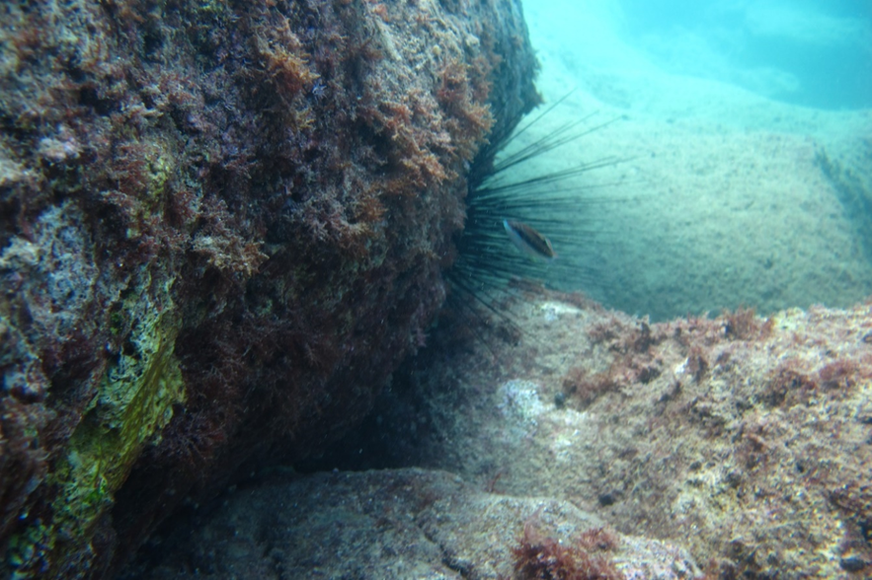
Figure 1. D. setosum colony and refugee fish individuals encountered during dives in rocky cliff areas

In the observations and counts we made in this region, the fish that use sea urchin as a shelter are species such as C. chromis juveniles (length 1-2 cm), C. novemstriatus, T. pavo, C. julis, T. melanurum, G. bucchichi. Of these species, C. novemstriatus originates from the Red Sea. According to our countings, the number of damselfish (C. chromis) juveniles using sea urchins as a shelter ranged between 80-140 and an average of 126 individuals were found.
The second most crowded species that uses the sea urchin as a shelter in the rocky area is C. novemstriatus, a cardinalfish species. In our study conducted in the summer months, it was seen that the adults and young individuals of this species use sea urchin as a shelter. This fish species was counted between 20-60 individuals among the spines of the sea urchin and it was found that 32 individuals could be hidden on average. It has been observed that some of the C. novemstriatus individuals who use sea urchins as a shelter during the summer months carry eggs in their mouths. The aggregation of other fish species among sea urchin spines was limited to a few individuals.
D. setosum colonies on the floors of the stony and gravelly bottom type in eastern part (36.53007 ⁰N; 30.404336 ⁰E) of Konyaaltı beach (Figure 2, 3).
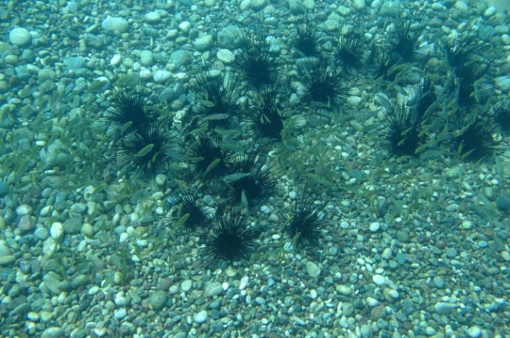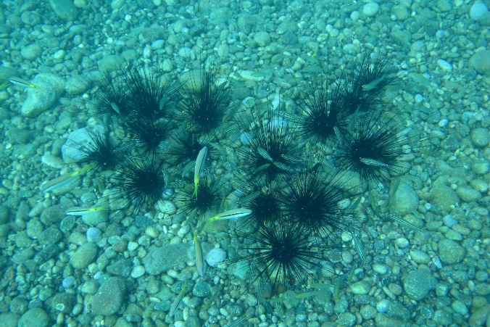
Figure 3. Sea urchins and individuals of P. forskalli colonized in the stony and gravelly areas of Konyaaltı beach

Figure 2. Sea urchins and juvenile S. rivulatus colonized in the stony and gravelly areas of Konyaaltı beach

In this region, sea urchins between 2-100 individuals (Average 24.35 individuals, 20 colonies) come together to form colonies. In this study, it was determined that the distances between the sea urchin colonies ranged between 5-20 m and there were many colonies in this region. In our research conducted here, it was determined that some fish species use sea urchins as shelters. C. novemstriatus, S. rivulatus, A. pharaonis, P. pelycus, P. forsskali, P. miles, S. rubrum, E. aeneus, C. julis are fish species using D. setosum as a shelter in stony and gravelly areas (Figure 4, 5).

Figure 5. A hidden E. aeneus among D. setosum individuals
Figure 4. A. pharaonis, S. rubrum and P. pelycus individuals, respectively, around a sea urchin

All of these species, except for E. aeneus and C. julis, are exotic for the Mediterranean and originating from the Red Sea. C. novemstriatus and A. pharaonis are cardinal fish species. Some individuals of both cardinal fish species that use sea urchins as a shelter during the summer months were observed their mouth filled with full of eggs (Figure 6).
Figure 6. An individual of P. miles found under the spines of sea urchin and cardinal fish carrying eggs in its mouth.

It has been observed that nocturnal species such as C. novemstriatus, A. pharaonis, P. pelycus and S. rubrum use the sea urchin in the Konyaaltı beach during the daytime, while other species use it as a shelter in case of danger. The average number of individuals by fish species in the counts of fish using D. setosum as a shelter, S. rivulatus 62, C. novemstriatus 53, A. pharaonis 0.75, P. pelycus 0.5, P. forskalli 0.3, C. julis 0.20, S. rubrum 0.041, P. miles 0.02, E. aeneus 20 (total number of individuals counted under sea urchins is 20) were found (Figure 7, 8).
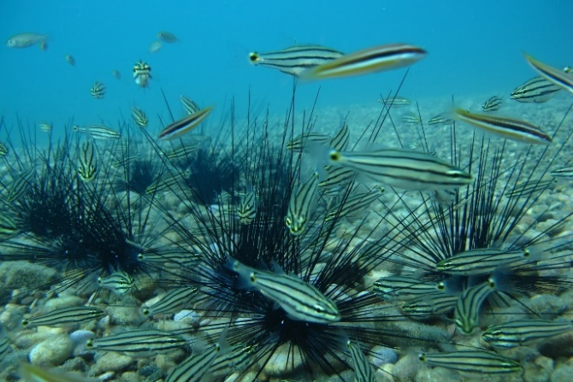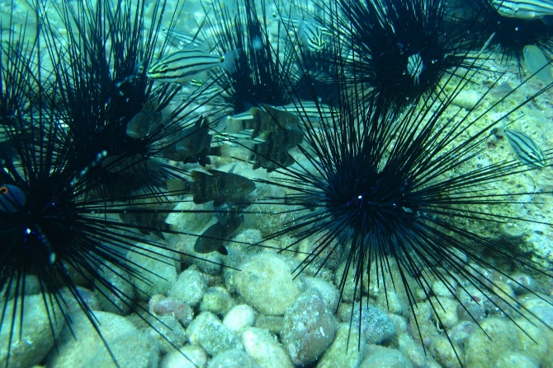
Figure 8. C. novemstriatus and A. pharaonis individuals and D. setosum colony

Figure 7. C. novemstriatus and C. julis individuals found around the sea urchin
colony

It was determined that adult and juvenile individuals of C. novemstriatus, A. pharaonis and P. pelycus used sea urchin as shelter, on the other hand the other species only juveniles use it.
Discussion
When the number of individuals of the species that use the sea urchin as a shelter is high, the counting technique from photographs and videos was used to determine the number, while the direct counting technique was used to determine the species with a low number of individuals. These methods are not consume nature and harmless to the ecosystem. Our research was carried out in rocky and non-rocky gravelly and stony regions. When the fish species in two different environments using the sea urchin as a shelter were compared, only C. novemstriatus was found as the common species. This fish is a species of cardinalfish and is one of the fish species that pass from the Red Sea to the Mediterranean.
According to this study we have done and the findings we have obtained, while the native fish species of the Mediterranean Sea use the sea urchin as a shelter in the rocky region, the Red Sea species are dominant in the gravelly and stony environment. According to Bilecenoğlu et al., (2019) found the fish species and numbers using sea urchins as shelters close to the species and values we detected in the rocky region. In another study conducted in the Iskenderun Bay, it was pointed out that D. setosum and C. novemstriatus have a symbiotic life (Ali Çiçek et al., 2020), indicating that the Mediterranean is in a rapid tropicalization process and that lessepsian species are rapidly adapting to the Mediterranean.
It was determined that adult and juvenile individuals of C. novemstriatus, A. pharaonis and P. pelycus used sea urchin as shelter, otherwise the other species only juveniles and young individuals are use it. C. novemstriatus and A. pharaonis are cardinalfish and it has been observed that they carry eggs in their mouths while they hiding between the spikes of sea urchin. Thus, it is thought that they protecting both themselves and their juveniles to be hatched, and also they have high reproductive ability. Cardinalfish are small and colorful fish of the seas and are generally nocturnal (Habib et al., 2020).
In our research, 9 species of fish were identified that use sea urchins as shelter in gravelly and stony environments. 7 of these fish are immigrant Red Sea species. In the rocky environment, this number was determined as 6. When the numbers of the detected fish species are compared, it is seen that the numbers in the rocky environment are low.
In our research, there is an increase in fish species and numbers that use sea urchins as shelter in gravelly and stony areas compared to the rocky area. This is due to the existence of environments where fish can be protected and sheltered in rocky areas in order to be protected from their enemies, and the absence of these environments in other areas, and that fish show hiding behavior between the spines of sea urchins in case of danger.

CONCLUSIONS
As a result; In this study, the majority of the fish that use the poisonous spines of the sea urchin as a shelter are species originating from the Red Sea. The rapidly increase of sea urchins in the Mediterranean and the shelter for these fish also contribute to the increase in fish species originating from the Red Sea.

REFERENCES
Ali Çiçek, B., Akbora, H.D., & Ayas, D. (2020). Does Symbiosis of Invasive Species Become Common Phenomena for the Mediterranean? Cheilodipterus novemstriatus (Rüppell, 1838) and Diadema setosum (Leske, 1778) is Observed Together in the Gulf of Iskenderun. Journal of Wildlife and Biodiversity, 4(Special issue), 13-18.
Artüz, M.L., & Artüz, O.B. (2019). First and northernmost record of Diadema setosum (Leske, 1778) (Echinodermata: Echinoidea: Diadematidae) in the Sea of Marmara. Thalassas: An International Journal of Marine Sciences, 35(2), 375-379.
Bilecenoğlu, M,, Baki Yokeş, M., & Draman, M. (2019). The invasive sea urchin Diadema setosum provides shelter for coastal fish–first observations from the Mediterranean Sea. Zoology in the Middle East, 65(2), 183-185.
Bronstein, O., & Kroh, A. (2018). Needle in a haystack—genetic evidence confirms the expansion of the alien echinoid Diadema setosum (Echinoidea: Diadematidae) to the Mediterranean coast of Israel. Zootaxa, 4497(4), 593-599.
Gökoğlu, M,, Balcı, B.A., Çolak, H., & Banbul, B. (2007). Akdeniz’de Uzun Dikenli Deniz Kestanesi’nin (Diadema setosum; Leske 1778) İkinci Kaydı. In SBT 2007, 11. Underwater Science and Technology Meeting.
Gökoğlu, M., Biçer, E., & Teker, S. (2022). Second record of the Blacktip Grouper Epinephelus fasciatus (Teleostei: Serranidae) in the Mediterranean Sea. Acta Aquatica Turcica (in press)
Habib, K.A., Islam. M.J., Nahar, N., Neogi. A.K., & Fraser, T.H. (2021). Three New Records of Cardinalfish (Apogonidiae) from the Northern Bay of Bengal, Bangladesh. Journal of Ichthyology, 61(4), 505-513.
Golani, D. (2021). An updated Checklist of the Mediterranean fishes of Israel, with illustrations of recently recorded species and delineation of Lessepsian migrants. Zootaxa, 4956(1), 1-108.
Kondylatos, G., & Corsini-Foka, M. (2015). Diadema setosum moving west to the Hellenic seas. New Mediterranean biodiversity records (October2015). Mediterr Mar Sci 16(3):691–692.
Nader, M.R., & Indary, S.E. (2011). First record of Diadema setosum (Leske, 1778) (Echinodermata, Echinoidea, Diadematidae) from Lebanon, Eastern Mediterranean. Aquatic Invasions, 6(1), S23-S25.
Pirkenseer, C,M. (2020). Alien species in southern Laconia, Kythira Island and southern Messenia (Greece): new and additional records and updated record maps. Journal of the Black Sea/Mediterranean Environment, 26(2).
Turan, C., Erguden, D., & Uygur, N. (2011). On the occurrence of Diadema setosum (Leske, 1778) in Antakya Bay, Eastern Mediterranean Sea. Journal of Black Sea/Mediterranean Environment, 17(1), 78-82.
Yapıcı, S., Acar, Ü., & Türker, A. (2014). First record of the alien sea urchin Diadema setosum (Leske, 1778) (Echinodermata: Echinoidea: Diadematidae) from the Aegean Sea. Mediterranean Marine Science, 15(3), 682.
Yokes, B., & Galil, B.S. (2006). The first record of the needle-spined urchin Diadema setosum (Leske, 1778) (Echinodermata: Echinoidea: Diadematidae) from the Mediterranean Sea. Aquatic Invasions, 1(3), 188-190.
Zenetos, A. (2019). Mediterranean Sea: 30 years of biological invasions (1988-2017). In 1st Mediterranean symposium on the non-indigenous species (p. 13). Antalya, Turkey, 17-18 January 2019

