STATEMENT LETTER

By this we registered a scientific paper to be published in Indonesian Fisheries Research Journal managed by the Center for Fisheries Research and Development, with the title: POSSIBLE USE OF LENGTH-BASED SPAWNING POTENTIAL RATIO FOR SKIPJACK (Katsuwonus pelamis) IN INDONESIA’S ARCHIPELAGIC WATERS. The data we use is the result of our research activities research A port-based sampling program, a collaboration between Indonesia and the Western and Central Pacific Fisheries Commission (West Pacific East Asia – WPEA project) in year 2010-2015.
The scientific papers that have not been published and have been approved by the co author (author 2nd etc.) are involved in research activities mentioned above.
Thus Statement is made to be used accordingly.
Jakarta 4 September 2017
The first author,
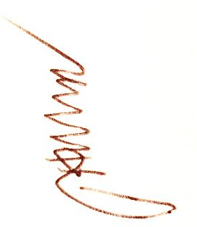
Fayakun Satria

Approve: Knowing:
- Author 2: Lilis Sadiyah Ka. Institute/Agencies /Researcher Head/
Preceptor Lecturer
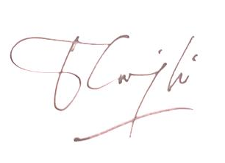

- Author 3: .................. .. (........................ ..)

