**Estimates of Length-Based Population Parameters of Skipjack tuna (*Katsuwonus pelamis,* Linnaeus 1798) FROM A pole & line fishery in Maumere-SIKKA, Indonesia**

[1]\***Agus Setiyawan1,2, Michael A. Rice2, Fayakun Satria3, Agustinus Anung Widodo1**

1Center for Fisheries Research, Ministry for Marine Affairs and Fisheries, Gd. Balitbang II, Pasir Putih 2, Ancol Timur, 14430 Indonesia

2Dept. Fisheries, Animal and Veterinary Science, University of Rhode Island, 9 East Alumni Ave. Kingston, RI 02881 USA

3Research Institute for Marine Fisheries, Ministry for Marine Affairs and Fisheries, Nanggewer Mekar, Cibinong Bogor, Jawa Barat 16912 Indonesia

**ABSTRACT**

Several population parameters of skipjack tuna (*Katsuwonus pelamis*) taken by pole and line gear from Maumere Waters from March 2017 to February 2018 were analyzed. A total of 2,194 skipjack tuna was sampled randomly. Fishing activities were carried out around FADs (*Fish Aggregating Devices*) and free fish shoal. Observers and enumerators collected data from several landing sites and by direct on-board observations. This study aims to provide length-frequency distribution by each of three annual seasons, estimate growth mortality parameters, and estimate stock exploitation rate using FISAT software. The results showed that the total catch was dominated by skipjack tuna; up to 80% with the CPUE of 30.8 kg/person/trip, and the skipjack tuna's length distribution ranged from 26 to 69 cm FL. Length at first capture (*Lc*) was 34.71 cm FL, and immature fish dominated the total catch with 53%, indicating growth overfishing. The calculated von Bertalanffy growth (VBG) parameters were *L∞* = 70.35 cm, K = 0.55 yr-1, and t0 = -0 .39 yr. Natural mortality (*M*) was estimated to be 0.92, and fishing mortality (*F*) was 0.91. The mean apparent longevity of skipjack tuna is estimated to be 3.2 years, with an exploitation rate (*E*) of 0.50. Sustainable exploitation of skipjack tuna determined from this analysis could be developed with an Emax of 0.73. There is a focus on reducing the catch of immature fish through various methods that include changing the fishing target area from FADs to fishing on natural fish shoals and using gear modifications such as larger-sized (lower number) hooks.

**Keywords:** Pole & line fishery, skipjack tuna, population dynamics, Maumere-Sikka, Indonesia,

**Introduction**

Skipjack tuna, *Katsuwonus pelamis,* is a relatively short-lived, tropical, epipelagic, and highly migratory species distributed primarily in seas with temperatures above 15oC (Collette and Nauen, 1983). FAO reported that the skipjack tuna is the largest tuna fishery worldwide, with 58% of the total catch compared to the other tuna species (FAO 2016). In Indonesia, tuna and other fisheries are managed regionally in Fisheries Management Areas (FMAs) described by Pomeroy *et al*. (2019).

In the Banda Sea, fishing gear used in skipjack tuna harvest includes purse seines, gillnets, troll lines, and pole & lines (Tampubolon, 1990), with a majority of the catches coming from purse seines. In 2018, skipjack tuna's total production in the Banda Sea (FMA 714) was 172,835 tonnes (MMAF statistics 2019).

Pole & line fishing is presumed to be a highly selective gear type compared to the other harvest methods. The technique frequently captures predominantly mature skipjack (*Lm* = 49.3cm FL), produces a high-quality product, and is relatively safe for participating fishers (Nugraha & Rahmat 2008; Nanholy, 2013). Currently, the status of tuna stocks in Indonesian waters is officially considered “*moderate*” (ranging from no overfishing to overfished, MMAF Decree`#50 (2017). However, pole & line fishing is one of the two methods explored to promote more sustainable tuna fisheries in Indonesian waters (Setiyawan *et al*., 2016). Various factors limit the viability of pole & line fishing in any given geographic area, and the availability of live bait is a crucial one. Artificial lures are also useful to attract tunas. However, they are not as effective as the live bait that is preferred by most pole & line fishers (Susanto *et al*., 2012). The other method promoted as a sustainable means of tuna harvesting is purse seining with control of mesh size in the net bunt. Purse seining does not require live-bait, but it is arguably less sustainable due to presumed lack of selectivity. There are trade-offs in choosing between the two recommended methods to catch tuna in a sustainable way (Resma *et al*., 2006).

Understanding the relationship between fish population structure and stock status is essential for policy makers and stock managers to inform fisheries management recommendations and subsequent policymaking. Population dynamic parameters, including temporal distribution of length frequencies, age, growth, and mortality, are necessary for any reliable stock assessment and ensure sustainable fisheries (Chen and Paloheimo, 1994). There is a considerable paucity of data about the skipjack tuna populations on FAD structures and growth performance in the Flores (Indonesia FMA 713) and Banda Sea Regions (Indonesia FMA 714). Currently, international treaty organizations, the Western and Central Pacific Tuna Commission (WCPFC) and the Indian Ocean Tuna Commission (IOTC), are responsible for coordinating all tuna species' international management. Hence, as a member of both organizations, Indonesia cooperatively provides tuna data collection for the Southeast Asian regional pelagic fish management efforts.

In this research, an investigation was made on important population dynamic features of skipjack tuna using length-frequency data from pole & line vessels in Maumere-Sikka within the Flores and Banda Seas. The main objective of this study is to provide the length-frequency distribution by season, growth parameters, estimates of mortality, and the exploitation rate using the Electronic Length-Frequency Analysis (ELEFAN) I technique. The results are expected to provide data about skipjack tuna resources in the Maumere-Sikka and make recommendations for sustainable tuna fishery management policies for the region.

***Table 1. Data Summary of the Maumere on-board fishery observer program in 2017.***

|  |  |  |  |  |  |  |  |
| --- | --- | --- | --- | --- | --- | --- | --- |
| Data Summary | | | | | | | |
| No | Month | Fishing Ground | Live bait | Total Bait (kg) | Total Fishing | Total Catch (kg) | Fishing Area |
| 1  2  3  4  5  6  7  8  9  10 | March  April  May  June  July  August  September  October  November  December | Flores Sea  Banda Sea  Banda Sea  Flores Sea  -  Flores Sea  -  -  Flores Sea  Banda Sea | Anchovy  Anchovy and Lure  Anchovy  Anchovy  -  Anchovy and Lure  -  -  Anchovy and Lure  Anchovy | 64  48  24  42  -  14  -  -  4  26 | 6  13  5  1  -  3  - -  1  2 | 5920  8700  2200  700  -  1010  -  -  200  1500 | Shoaling  FADs and Shoaling  FADs and Shoaling  Shoaling  -  FADs and Shoaling  -  -  Shoaling  FADs |

Note: “ - “; No data available

**MATERIALS AND METHODS**

The pole & lineskipjack tuna fishery in Maumere-Sikka (in an area around 8oS, 122oE) was monitored during 2017 by observers on-board who recorded catch numbers and fork lengths (cm FL) of individual fish (Table 1). The sample was obtained at each landing site every month from the commercial and private vessels, which landed in several ports in the Sikka Regency, including Wuring fishing port, the Karya Cipta Buana Sentosa (KCBS) Company, and other local fishing ports by enumerators. The data on FL, the number of trips, total catch, and the amount of live bait they used were recorded.

A total of 2,194 skipjack tuna were sampled randomly from the catches. Nominal catch per unit effort (CPUE) was calculated by the number of total catches per trip along with the number of on-board fishers and reported as kg catch/person/trip.

The von Bertalanffy growth parameters, L∞, and K were calculated from monthly data using ELEFAN-I programmed in FISAT software (Sparre and Venema, 1991), and the t0 value is predicted by the empirical formula (Pauly, 1983). A total of 1,710 skipjack tuna measured were in the length range of 25 – 69 cm FL and used for the t0 estimation. The length-frequency distribution was plotted with the open-source statistical package “R” (R Core Team 2019). The estimate of length at first capture was obtained from the length-frequency distribution.

The maximum length of fish (Lmax) was predicted using the Maximum Length Estimation routine from the support menu of the ELEFAN-I software program. The best value of growth parameter (K) for the given value of Lmax was identified by Shepherd’s method when we used a scan of the K-values option from the assess menu. The Bertalanffy growth function (VBGF) (von Bertalanffy 1938; Sparre and Venema, 1998) was fit to the data using the von Bertalanffy formula:



In this equation, t0 represents the theoretical age at length zero, L∞ is the asymptotic length, and *Lt*is the fish length at age *t*. The parameter L below was taken from the Powell-Wetherall plot, which used length frequencies data with equation given thus:



When b is the slope, and a is the intercept of the regression. The estimation of length at age was calculated by the equation:

Log(*-t0*) = -0.3922 – 0.2752log*L∞* - 1.038log*K*

When :

Lt = fish length at age, *t* in years;

L∞ = length-at-infinity in cm;  
K = von Bertalanffy growth coefficient in yr-1;

t = time in years;  
t0 = theoretical age at which the fish length equals zero.

The FISAT – ELEFAN I (Pauly and David 1981; Yang *et al*., 2013) and Pauly’s empirical formula was used to estimate natural mortality (M) (Pauly, 1980). The FISAT software uses the length frequency of skipjack to estimate the asymptotic length (*L∞*), growth rate (*K*), natural mortality (*M*), total mortality (*Z*), fishing mortality (*F*) and exploitation ratio (*E*).

Total mortality (Z) was analyzed by catch curve and it was converted by length (Length Converted Catch Curve Analysis) in the FISAT – ELEFAN I (Pauly and David 1981; Brey and Pauly 1986; Yang *et al*., 2013). The analysis was taken by the data input of growth parameters (length infinity and K) as Beverton & Holt (1956) equation:

Z = K(L∞-L”)/(L”-L’)

When:

Z = total mortality rate (year-1) K = growth coefficient (year-1)

*L∞ =* asymptotic length of fish (cm)

L” = average length of fish catch (cm)

L’ = lower limit of the highest catch class length interval (cm)

The natural mortality coefficient (M) was calculated by the empirical equation as follows:

*Ln M* = - 0.0152 – 0.279 ln *L∞* + 0.6543 ln *K* + 0.4634 ln *T*

When,

L*∞* is asymptotic body length (cm),

K is the von Bertalanffy growth coefficient (yr-1),

and T is the annual average water temperature of 28o C

It is well known that sea surface temperature will affect the growth of skipjack tuna (Barkeley et al., 1978). Since growth parameters are used in the estimates of mortality rates in this method, then it follows that mortality rates will also be temperature dependent. The fishing mortality has been calculated from M and Z as *F = Z-M*.

**RESULTS AND DISCUSSION**

**Results**

*Fisheries*

The pole & line fishery for tuna was introduced in North Sulawesi in the 1950s (Naamin et al. 1995). Since that time, the number of vessels has increased considerably, raising questions about the sustainability of the fishery. Data from the Ministry of Marine and Fisheries Affairs (KKP, 2016) showed that the total catch of tuna increased every year since 2000, with skipjack tuna as the predominant species caught. Pole & line fishing rely on live bait, consisting primarily of anchovies and sardines, but lures are sometimes used.

The typical pole & line fishing vessel is made of wood and fiberglass, and a water sprayer is attached to attract tuna during the fishing process. The sprayer is often used to induce “false shoaling” in the ocean, thereby increasing catch. Hook size chosen for fishing consists of the five, six, and seven-size types depending upon the preference of the fisher. Moreover, lures can be utilized as a “fake-bait” attached to the hooks as well.

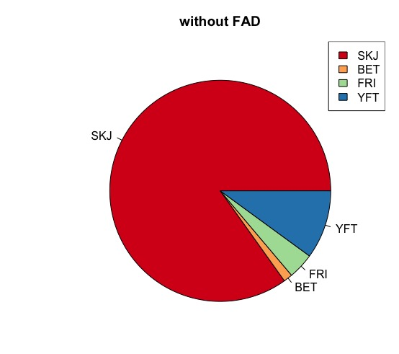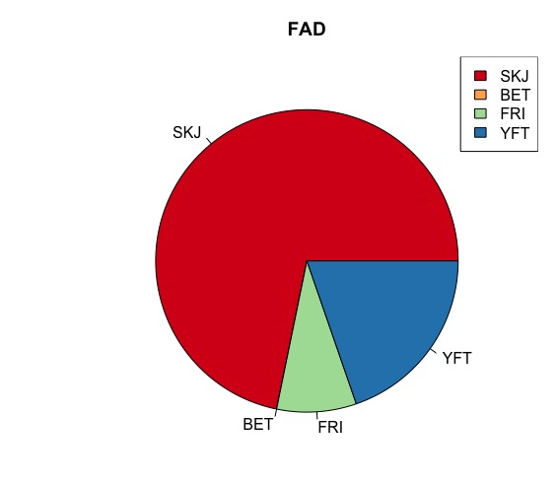

***Figure 1.*** The composition of catches from all sites with free schooling (n=815) and with FADs (n=1379); SKJ = Skipjack tuna; YFT = Yellowfin tuna; BET = Bigeye tuna; FRI = Frigate tuna).

Figure 1 presents the composition of catches from sites with FADs and free shoaling (free schooling). In areas with FADs and free shoaling, dominant catches in the pole & line fishery are of skipjack tuna: fish shoaling (85%) and FADs (72%). The relative percentages of yellowfin and frigate tuna catches are increased by the presence of the FADs, while bigeye tuna appear to avoid them.

*Fishing ground*

The fishing ground area in this research was focused in a region around 8oS and 122oE (Figure 2) within the Indonesia Fishing Marine Areas (FMAs) 714 and 713, with FMA 714 to the east, including the Banda Sea and Tolo Strait, with Maumere Waters belonging to the more westerly Indonesia FMA 713 in the Flores Sea. The westerly flowing equatorial current system dominates the currents pattern in the fishing grounds.



***Figure 2.*** The Pole & Line Fishing Ground in the Flores and Banda Seas. The boundary line (white line) between FMA 713 in the Flores Sea toward the west and FMA 714 toward the east in the Banda Sea is shown. The longitude & latitude grid represents 1o of arc, or 60 nautical miles (111.1 km). (Red dot: Fish Schooling, Green dot: FADs)

*Catch per unit effort (CPUE)*

The total trip frequency of pole & line vessels every month fluctuated depending on the availability of live-bait. The magnitude of the nominal *catch per unit effort* (CPUE) is 30/kg per fishers for a single trip. Currently, there is no known standard for calculating CPUE for pole &

line fisheries. In this research, CPUE is calculated based on the total catch per trip, divided by the number of fishers who were fishing (called nominal CPUE). The number of anglers was determined from the number of fishers who were actually fishing per trip by the logbook. The trip is defined as the summation of gear sets in a day to catch fish; usually, there are two or three gear sets per day.

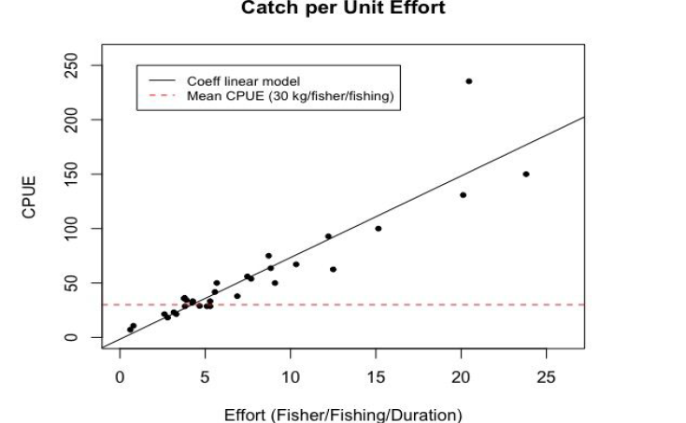

***Figure 3.*** *Catch per Unit Effort* (CPUE) as a function of effort in the pole & line fishery in Maumere-Sikka. (dashed line is the mean CPUE; solid line: Coefficient linear model)

*Length distribution*

The exploited size range of caught skipjack tuna is 26 to 69 cm FL. The length distribution for skipjack tuna displayed in Figure 5A is dominated by sizes ranging from 25 – 39 cm FL. However, the number of samples calculated in this research is limited and analyzed carefully.

A)

A)



B)



***Figure 4.*** (A) The rough length-frequency distribution (L in cm) of skipjack tuna by season, (B) The overall distribution (L in cm) of skipjack tuna in Sikka-Maumere using pooled data.

The size category in Figure 4 illustrates the fork length distribution of skipjack tuna in the catch. The length-frequency ranging from 25 to 39 cm FL is maximum in March to June, but in later months (July and October), the major size range is 40 to 54 cm FL.

*Length at First Capture (Lc)*

The probability of capture analyses provides an estimate of mean size-at-first capture (*Lc*) for skipjack tuna to be 34.71 cm FL, using the logistic transformation and running average methods, respectively (Figure 5).

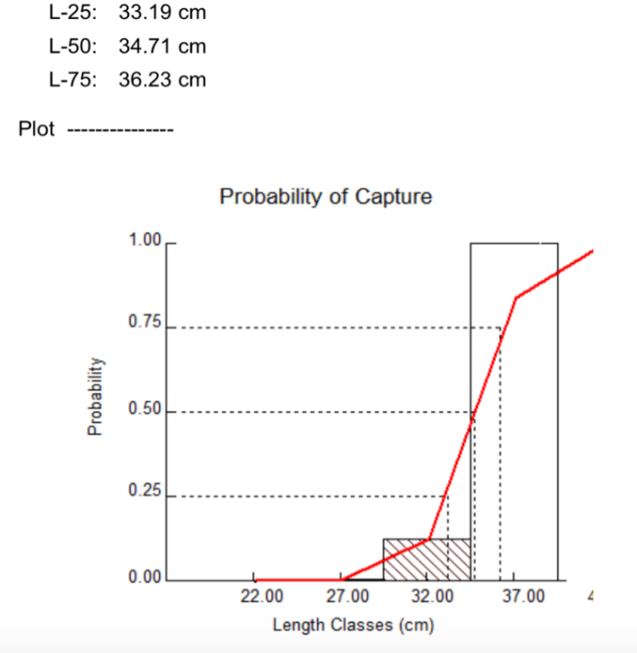

***Figure 5.*** Probability of capture by length class of skipjack tuna from the ascending arm of the catch curve (Y = -25.08 + 0.72X, r = 0.99). The length at first capture (dotted lines) were L50 = 34.71 cm FL, L25 = 33.19 cm FL, L75 = 36.32 cm FL by logistic transformation (a) and running average routines (b) respectively.

Skipjack tuna caught by pole & line gear type indicates that the composition of mature fish is 47%, and immature fish is 53% based on n = 2,194. The length of the range, Lmax, is 63.43 – 72.53 cm FL on a 95% confidence level and is predicted to be 67 cm FL (Figure 7). Accordingly, the K value was 0.55 year-1 (Figure 8). Length infinity (*L∞*) and *Z/K* were 70.35 and 3.3, respectively, by Powell-Wetherall plot (Figure 6).

  
***Figure 6.*** Powell-Wetherall plot for skipjack tuna in Maumere-Sikka identifies length at first exploitation. The regression line: Y =14.25 + (-0.18) * X identifies the first length at full exploitation (L’) of 64.5 cm FL, coinciding with the largest size grouping in the length-frequency data (rightmost in Figure 5A, ranging 55-69 cm FL).

The theoretical age at length zero (t0) of the von Bertalanffy model (von Bertalanffy, 1938) was estimated at -0.39 year. The longevity, tmax, of skipjack tuna was 3.2 years or 38 months, with a growth performance index (Pauly, 1991) of 3.32. The von Bertalanffy growth equation is written as:

Lt = 70.35 (1-e -0.55(t+0.39))

By adopting t0 = -0.39, the skipjack tuna's length was calculated at 69.73 cm FL and 70.34 cm FL or approximately 1 to 3 years, respectively. The skipjack tuna grows rapidly and reaches catchable size within one year.



***Figure 7.*** The ELEFAN I analysis for determining von Bertalanffy growth parameters of skipjack tuna stocks in Maumere-Sikka from March 2017 to February 2018.

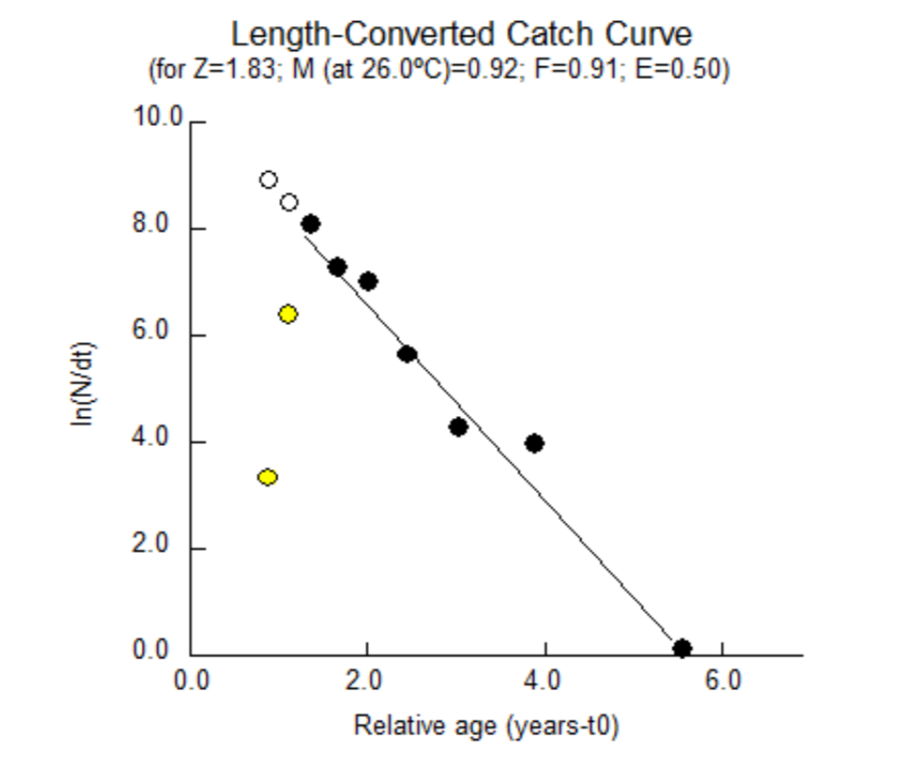

***Figure 8.***  The length-converted catch curve showing the relative age (years) to the fishing mortality (F), natural mortality (M), and the exploitation rate (E)

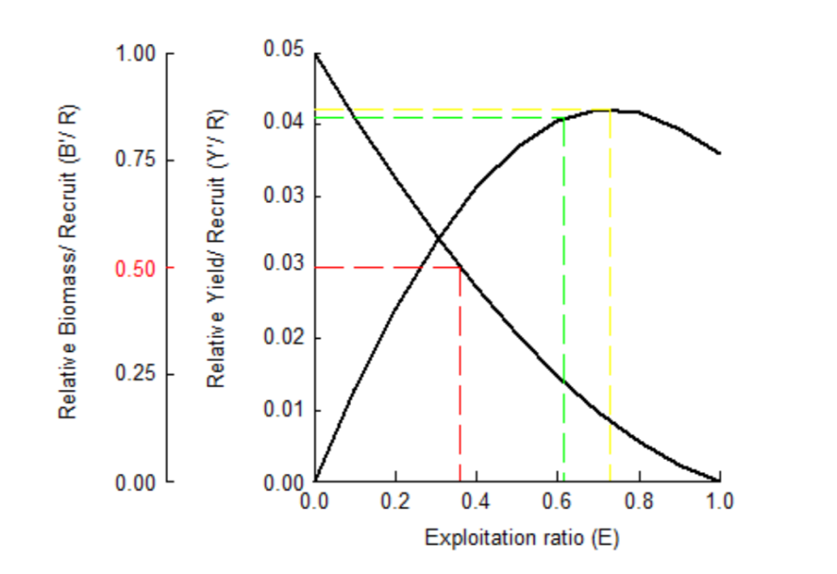

***Figure 9.*** An exploitation rate graph showing that E50 as 0.36, Emax as 0.73, and E-10 as 0.62

Natural mortality (*M*) was calculated to be 0.92 year-1, while fishing mortality (*F*) was 0.91 year-1. Taking *Z* = 1.83 into account, and exploitation level (*E*) of 0.50 year-1 obtained for skipjack tuna in the Maumere-Sikka waters is less than the optimum level of exploitation (Emax = 0.73) as shown in Figure 9.

**Discussion**

The present study shows the observed size range of skipjack tuna exploited by pole & line gear type in the Maumere-Sikka as 26 to 69 cm FL. The length range is in contrast to skipjack tuna's size harvested in the Flores Sea, ranging from 18 to 73 cm FL (Susaniati *et al*., 2014). But more similar to Tadjuddah *et al*. (2017), where they reported that the fork length of skipjack tuna taken from purse seine, trolling line, and pole & line gears in the Banda Sea ranging from 9 to 71 cm FL, which is quite similar (Figure 5).

***Table 3.*** Comparison of the length size for skipjack tuna among pole-and-line (PL) and purse seine (PS) based on the hook numbers and mesh size; not reported (n.r.).

|  |  |  |  |  |  |  |  |  |  |
| --- | --- | --- | --- | --- | --- | --- | --- | --- | --- |
| No | Gear | Mesh & Hook | Length Range | Mean Length | | Location | | Source | |
| 1  2  3  4  5 | PL  PL  PL  PS  PS | Hook: 5,6 and 7  Hook: 4 and 5  n.r.  Mesh: 3.5 inch  n.r | 26-69 cm FL  46-50 cm FL  18-73 cm FL  18–78 cm FL  30-70 cm FL | 40.5 cm FL  42 cm FL  n.r.  n.r  n.r | Flores Sea & Banda Sea  Sulawesi Waters  Flores Sea  Celebes & Bismarck Seas  Central Pacific Ocean | | Present study  Setiyawan *et al*. (2018)  Susaniati *et al*. (2014)  Resma *et al*. (2006)  Boyra *et al.* (2018) | |  |

There have been many similar studies of skipjack tuna in Indonesia and elsewhere. In a 2006 study of skipjack tuna catches using purse seine gear in the Celebes Sea and in the Bismarck Sea north of Papua, the greatest CPUE among skipjack tuna was in the 1.8 to 3.4 kg size range (Resma *et al*., 2006). The modal length of skipjack of 40 cm in the pole & line caught in this study corresponds to an individual weight of about 1.19 kg. In comparison, the mean catch length of 56.6 cm corresponds to a weight of 3.93 kg using allometric parameters (*a*) = 3.581 x 10-6 and (*b*) = 3.446, from data in Resma *et al*. (2006). The highest CPUE for skipjack tuna in both the purse seine and pole & line fisheries are in roughly the same size ranges.

The length at first capture (*Lc*) of skipjack tuna was calculated as 34.71 cm FL (Figure 5). In contrast, Setiyawan (2018) found that *Lc* of skipjack tuna is 43.36 cm FL in the Pacific Ocean. If compared to the length at maturity (*Lm*) of 40 cm FL (Tandog-Edralin et al. 1990; Froese and Pauly, 2019), the skipjack tuna is experiencing growth overfishing and immature fish caught during the fishing still represents 53% of the total catch.

Our data suggest that the fishing method alone is not solving the problem of overfishing since such a high percentage of immature fish are being caught. To improve upon the

sustainability of the fishery, the size of the hook to be used in the pole & line should be carefully considered since evidence suggests that larger-sized hooks (with a smaller number) tend to catch larger fish. Setiyawan (2016) found that in the Sulawesi and Maluku Waters, the pole & line fishers use hook sizes #4 and #5 that are larger-sized hooks than in the present study. The mean fish length of fish caught in Sulawesi and Maluku waters is larger. Given the high number of juveniles caught in the Maumere pole & line fishery, reducing the numbers of the juveniles being caught is necessary to boost the reputation of this gear type as being a more “environmentally friendly” way of catching skipjack tuna in comparison with purse seining or any other fishing gear types.

Interestingly, Satrioajie *et al*. (2018) suggested that the Banda Sea should be considered a conservation area for the tuna population since tuna spawning grounds have been found in this area. Tuna tagging programs were conducted in 2009 by the Pacific tuna tagging project (Nicol *et al*., 2010). They have shown that smaller tuna found in the Banda Sea will afterward as larger adults migrate to the North, toward the Celebes Sea, and northwesterly into the open Pacific Ocean. This pattern is also borne out in Resma *et al*. (2006), who showed that considerably larger skipjack tunas are found in the Bismarck Sea area north of Papua Waters and the Celebes Sea northwest of North Sulawesi. Our data showing the longevity of 3.2 years with length infinity 70.35 cm FL is comparable with Tajduddah et al. (2017) in the Banda Sea at 3.7 years. They assumed that skipjack tuna devotes energy to reproduction and growth before reaching length infinity. If our data is compared with average length at maturity globally of 40 cm FL, the skipjack tuna has a chance to reproduce almost two times before reach the length infinity with most of its energy is devoted to growth and reproduction, so it would make sense that skipjack tuna population in Banda have high fecundity because they are capable of producing large numbers of offspring.

As we found, the pole & line fisheries are not as “environmentally friendly” as assumed initially because of the high percentage of immature skipjack in the catch. A similar research result by Resma *et al*. (2006) showed that purse seines also resulted in considerable landing of immature skipjack. Still, they recommended that a gradual increase in the mesh size of the bunt on purse seines from the 3.5 inches (8.9 cm) spacing from their study up to as much as 8 inches (20.3 cm) as a strategy to exclude smaller immature skipjack from the catch in the multispecies tuna fisheries, thus improving the sustainability of that method. Pole & line gear are generally more selective than purse seines, but they can be more selective for mature skipjack depending upon hook size. Pole & line fisheries may have the advantage of allowing for regulations requiring a release of smaller skipjack tuna immediately upon landing and unhooking. A good fisheries management strategy for skipjack tuna in the Eastern Flores and the Banda Sea region may change the fishing gear from purse seine to pole & line, particularly in waters likely to be within identified spawning areas. In these waters, skipjack tuna is often a by-catch in a purse seine fishery that is mainly targeting carangids and other small pelagic fishes.

The growth pattern of skipjack tuna seems to be different depending on different fishing grounds within FMA 714. Yearly growth rate consultations are made in the WCPFC Working Group or Scientific Committee Meeting for compliance with the international treaty obligations. Studies in different Pacific Ocean areas, including the Banda Sea, have indicated that the L∞ varies from 61.3 to 144 cm FL, while the range of K was 0.1 to 1.3 yr-1. Our results (L∞ = 70.35 cm FL and K = 0.55 yr-1) are consistent within these ranges (Table 4) and the rapid growth rate of skipjack tuna, mirroring similar findings by other authors.

***Table 4. Growth parameters calculated for skipjack tuna in different areas***

|  |  |  |  |  |  |
| --- | --- | --- | --- | --- | --- |
| Location/Area | *L∞*(cm) | K (year-1) | t0 | Methods | Source |
| Maumere Waters  South Atlantic  Andaman Waters  Banda Sea  Banda Sea  Banda Sea  Western Pacific  Worldwide mean (n=61) | 70.35  90.1  74.6  70.1  97.6  75.9  93.6  82.6 | 0.55  0.24  0.59  0.26  0.41  0.19  0.43  0.54 | -0.39  -0.54  -0.21  0.49  0.29  0.36  -0.49  -0.19 | Length frequency  Length frequency  Length frequency  Length frequency  Length frequency  Length frequency  Otolith  Various | Present, (2019)  Soares *et al.* (2019)  Divakar *et al*. (2017)  Tadjuddah *et al*. (2017)  Wailenury *et al*. (2014)  Jamal *et al*. (2011)  Tanabe *et al*. (2003)  Froese & Pauly (2019) |

The natural mortality estimation of skipjack tuna seems constant, ranging from 0.7 year-1 to 0.8 year-1 (Koya *et al.*, 2012) compared to different fishing grounds in the Indian Ocean. In a WCPFC working paper, Rice *et al*. (2014) showed that the fishing mortality has generally been increasing recently, with Fcurrent estimated to be 0.61 times higher than the fishing mortality that will support *Maximum Sustainable Yield* (MSY). In the estimation in the present study, fishing mortality (*F*) was 0.91 year-1, indicating that the fishing pressure is occurring with more than 50% of the catch being immature fish. Overall, the pole & line fishery is recommended as the preferred gear type to catch skipjack tuna in Maumere-Sikka, given its proximity to presumed spawning grounds, especially in the Banda Sea area (Satrioajie *et al*., 2018). However, an analysis of live-bait availability must be undertaken if an economically viable pole & line fishery were to be further developed. Reducing the immature and juvenile fish caught is also critical for a sustained pole & line fishery.

The majority of skipjack tuna caught is reported as 51,994 tons of total catch in 2004 by purse seine, troll line, gillnet, and pole & line gear type landed in Sulawesi Sea (Wudianto *et al.*, 2006). One practical management strategy is to enforce bans on gear types that have been demonstrated to be environmentally unfriendly to optimally harvest skipjack tuna and prevent the probability of stock collapse. Promotion fishing gears with skipjack free shoaling and offering disincentives for the use of FADs to reduce more significant percentages of juvenile fishes are being caught (Setiyawan *et al*., 2018). There are also considerable numbers of immature ~~and juvenile~~ skipjack tuna being caught from fish shoals, suggesting that fishing effort controls may ultimately be necessary to protect the stocks, regardless of gear type. Institution of a fishing season for FADs may be one strategy for consideration, particularly during the early months of the year when juvenile fish are dominant (Figure 5A). Further studies are needed to directly compare the effects of fishing methods used to determine growth parameters and exploitation rate are needed to improve the utility of the data for deriving fisheries management recommendations.

***CONCLUSION***

The length distribution of skipjack tuna in the pole & line fishery was dominated by the size of 26-69 cm FL. The total catch composition was dominated by skipjack tuna up to 80% with a CPUE of 30.8 kg/person/trip. Length at first capture (*Lc*) is 34.71 FL-cm. The pole & line fishing method has less by-catch during fishing compared to purse seine and other methods, but there is still a need to reduce the number of immature or juvenile fishes caught. The Von Bertalanffy growth function (VBGF) for skipjack tuna at Maumere were *L∞* = 70.35 cm, *K* = 0.55yr-1, and t0= -0.39 yr. The apparent longevity of skipjack tuna was calculated as 3.2 years or 38 months. Finally, the estimate of total mortality (*Z*) was 1.83 yr-1, natural mortality (*M*) 0.92 yr-1 fishing mortality (*F*) 0.91 yr-1 The exploitation ratio (*E*) was low as 0.50. The

recommendation for sustainable fisheries is to maintain the skipjack tuna catch below Emax of 0.73 and reduce the number of juvenile fishes caught by managing fishing grounds with FADs. We are encouraging targeting of wild fish schools and increasing awareness on the use of larger hook sizes.

***ACKNOWLEDGMENTS***

The authors are thankful to The Center Research for Fisheries, Ministry of Marine and Fisheries Affairs who provide the data, and grateful to observers and enumerators who collected the data under WCPFC-WPEA Project Maumere-Sikka and also thankful to KCBS company has provided additional data. The authors are also thankful to Dr. Kathleen M. Castro of the URI-FAVS Department to critique earlier versions of this manuscript. Thanks are given to Dr. Jason McNamee, Deputy Director of the Rhode Island Department of Environmental Management, to read the paper and offer valuable suggestions.

**REFERENCES**

Barkeley R.A., W.H. Neil, & R.M. Gooding. (1978). Skipjack tuna, *Katsuwonus pelamis*, habitat based on temperature and oxygen requirements. *Fish. Bull., U.S.* 76:653-662.

Bertalanffy, L. von. (1938). A quantitative theory of organic growth (inquires on growth laws II). *Human Biol.* 10:181-213.

Boyra G., G. Moreno, G. Sobradillo, I.P. Arjona, I. Sancristobal, & D.A. Demer. (2018). Target strength of skipjack tuna (*Katsuwonus pelamis*) associated with fish aggregating devices (FADs). *ICES J. of Mar. Sci.* 75(5):1970-1802.

Brey, T. & D. Pauly. (1986). A user's guide to ELEFAN 0, 1 and 2 (revised and expanded version). Berichte des Institut für Meereskunde an der Universität Kiel, No. 149, 77 p.

Beverton, R.J.H. & S.J. Holt. (1956). A review of methods for estimating mortality rates in exploitation fish population, with special reference to source of bias in catch sampling. *Rapp. P.-v Reun. CIEM*, 140:67-83.

Chen, Y. & J.E. Paloheimo. (1994). Estimating fish length and age at 50% maturity using a logistic type model. *Aquatic Sci.* 56:206–219.

Collette, B.B. & C.E. Nauen. (1983). FAO species catalogue. *Scombrids* of the world. An annotated and illustrated catalogue of tunas, mackerels, bonitos and related species known to date. *FAO Fish. Symp.* 125(2):137.

Divakar P.H., S.S. Shirke, & B. Kar. (2017). Estimates of length-based population parameters of the skipjack tuna, *Katsuwonus pelamis* (Linnaeus 1778) in the Andaman Waters. *J. Fish.* 5(2):477-482.

FAO. (2016). State of the World Fisheries and Aquaculture. Food and Agriculture Organization, Rome. 200pp. ISBN 978-92-5-109185-2

Froese, R. & D. Pauly eds. (2019). FishBase. World Wide Web electronic publication. *www.fishbase.org*, version (08/2019).

Jamal, M., M.F. Sondita, S. Huluan, & B. Wiryawan. (2011). (in Indonesian). Utilization of biological data of skipjack tuna (*Katsuwonus pelamis*) in the framing of responsible fisheries in the Gulf of Bone. *J. Natur Indonesia* 14(1):107-113.

KKP. (2016). KPDA. Pusat Data dan Statistik. Kementerian Kelautan dan Perikanan.

Koya, S.K.P, K.K. Joshi, E.M, Abdussammad, P. Rohit, M. Sivadas, S. Kuriakose, S. Ghosh, M. Koya, H.K. Dhokia, D. Prakasan, V.A.K Koya, and M. Sebastine. (2012). Fishery, biology and stock structure of skipjack tuna, *Katsuwonus pelamis* (Linnaeus, 1758) exploited from Indian waters. *Indian J. Fish.* 59(2):39-47.

MMAF. (2017). Ministerial Decree, No. 50/KEPMEN-KP/2017 about Estimation Stock, Total Allowable Catch (TAC) and the Utilization rate in the Indonesian Fishing Marine Areas (FMAs). Ministry of Marine Affairs and Fisheries. The Republic of Indonesia.

Naamin N., C.P. Mathews., & D. Monintja. (1995). Studies of Indonesian tuna fisheries, part 1: Interactions between coastal and offshore tuna fisheries in Manado and Bitung, North Sulawesi. Status of interactions of Pacific tuna fisheries in 1995. FAO Fisheries Technical Paper. 282-294pp.

Nanlohy C.A. (2013). (in Indonesian) The evaluation of fishing gear of pelagic fish which environment friendly in Maluku waters by CCRF (Code of Conduct for Responsible Fisheries). *J. Ilmu Hewan Tropika*, 2(1):1-11.

Nicol S., A. Lewis, D. Itano, T. Usu, B. Kumasi, B. Leroy, S. Calliot, C. Sanchez, & J. Hampton. (2010). Pacific tuna tagging project progress report and work plan for 2010. Scientific Committee Sixth Regular Session. Nuku’alofa, Tonga 10-19 August 2010. WCPFC-SC6-2010/GN IP-04.

Nugraha B., & Rahmat E. (2008). (in Indonesian) The Pole-and-line fishery status in Bitung, North Sulawesi. *J. Penelitian Perikanan Indonesia (JPPI)* 14:313-320.

Pauly, D. (1980). On the interrelationships between natural mortality, growth parameters, and mean environmental temperature in 175 fish stocks. *J. Cons. CIEM* 39(2):175-192.

Pauly, D & N. David. (1981). ELEFAN I, a BASIC Program for the objective extraction of growth parameters from length frequency data. *Meeresforschung* 28 (4):205-211.

Pauly, D. (1983). Some simple methods for the assessment of tropical stocks. FAO Fish. Tech. Pap. (234): 52 pp.

Pauly, D. (1991). Growth performance in fishes: Rigorous descriptions of patterns as a basis for understanding causal mechanism. *Aquabyte* 4(3):3-6.

Pomeroy, R.S., L. Adrianto, G. Yusuf. S.Nugroho, T. Ruchimat, J. Kalther, and U. Muawanah. (2019). Review of national laws and regulations in Indonesia in relation to an ecosystem approach to fisheries management. *Mar. Policy* 91:150-160

R Core Team. (2019). R: A language and environment for statistical computing. R Foundation for Statistical Computing, Vienna, Austria. URL https://www.R-project.org/.

Resma, S. E., J.T. DeAlteris., M.A. Rice. (2006). Size selectivity of purse seine in the Southern Philippines multispecies tuna fisheries. *J. Aquatic Sci.* (Cebu, Philippines) 3:1-21.

Rice J., S. Harley, N. Davies, & J. Hampton. (2014). Stock assessment of skipjack tuna in the Western and Central Pacific Ocean. Scientific meeting. WCPFC-SC10-2014/SA-WP-05.

Satrioajie W.N., Suyadi, A. Syahailatua, & S. Wouthuyzen. (2018). The importance of the Banda Sea for tuna conservation area: a review studies on biology and the ecology of tuna. International Symposium on Banda Sea Ecosystem (ISBSE) 184. http://doi.org/10.1088/1755-1315/184/1/012004

Setiyawan, A., L. Sadiyah, & S. Samsuddin. (2016). (in Indonesian). The important factors influencing the CPUE of pole and line fishery based in Bitung. *J. Penelitian Perikanan Indonesia* (JPPI) 22 (1):43-50.

Setiyawan, A., A.A. Widodo, F. Satria, C. Nainggolan, & S.P. Mandak. (2018). The effectiveness of FADs (Fish Aggregating Devices) for pole-and-line fishery in biological aspects based in Bitung, Indonesia. Proceeding of the 9th International Fisheries Observer and Monitoring Conference (IFOMC). 51-54p. ISBN:978-0-9924930-7-3. Vigo-Spain.

Soares J.B. (2019). Size structure, reproduction, and growth of skipjack tuna (*Katsuwonus pelamis*) caught by pole-and-line fleet in the Southwest Atlantic. *Fish. Res.* 212:136-145.

Sparre P. & S.C. Venema. (1998). Introduction to Tropical Fish Stock Assessment, Part 1, Manual. FAO Fisheries Technical Paper. 306.

Susaniati W., A. Mallawa, & F. Amir. (2014). (in Indonesian). Study of population biology of skipjack tuna (*Katsuwonus pelamis*) in the waters of Flores Sea, South Sulawesi. *Proceedings. Symposium Pengelolaan Perikanan Tuna Berkelanjutan*, Denpasar. 162-170p.

Susanto Y.E., H. Boesono, & A. Dian. (2012). (in Indonesian) The live-bait influences to the total catch of skipjack tuna (*Katsuwonus pelamis*) on pole-and-line fishery in Ternate waters North Maluku. *J. Fish. Res. Utilization Management Tech*. 1:138-147.

Tajuddah M., L. Anadi, A. Mustafa, H. Arami, Abdullah, S. Kamri, & N.I. Wiyanti. (2017). Growth pattern and size structure of skipjack tuna caught in Banda Sea, Indonesia. Aquaculture, Aquarium, Conservation, & Legislation – *Internat. J. Bioflux Soc.* 10(2):227-233.

Tampubolon, N. (1990). (In Indonesian]. Study of skipjack tuna and *Thunnus* sp fishing and possible development in Pelabuhan Ratu, West Java. MSc Thesis. Bogor Agricultural University, Bogor, Indonesia.

Tanabe T., S. Kayama, & M. Ogura, (2003). An outline of the growth study on skipjack tuna (*Katsuwonus pelamis*) in the Western Pacific*. IOTC Proceedings* 6:156-164.

Tandog-Edralin, D.D, E.C. Cortez-Zaragosa, P. Dalzell, & D. Pauly. (1990). Some aspects of the biology and population dynamics of skipjack (*Katsuwonus pelamis*). *Asian Mar. Biol.* 7:15-29.

Wailenury, W., D. Duminggas, and P. Matrutty. (2014). (in Indonesian). Legal size and temporal dynamics of skipjack tuna in Banda Sea and surrounding Maluku Province. *Proseding Simpoium Pengeloaan Perikanan Tuna Berkelanutan, Denpasar*. pp. 240-251.

Wudianto, & D. Retnowati. (2006). Indonesian tuna fisheries in Sulawesi Sea and Western Pacific Ocean Waters. Annual report part 1- Information on fisheries, research, statistics Indonesia. Scientific committee second regular session. 7-18 August 2006 in Manila, Philippines.

Yang, X., S. Gubian, B. Suomela, & J. Hoeng. (2013). Generalized simulated annealing for global optimization: the GenSA package. *J. Mech. Eng*. 5:153-160.

1. * deceased