Supplementary Materials
“Coral recruitment on artificial patch reefs deployed in the marginal reefs: effect of multilevel substrate on density of coral recruit” by Munasik et al.

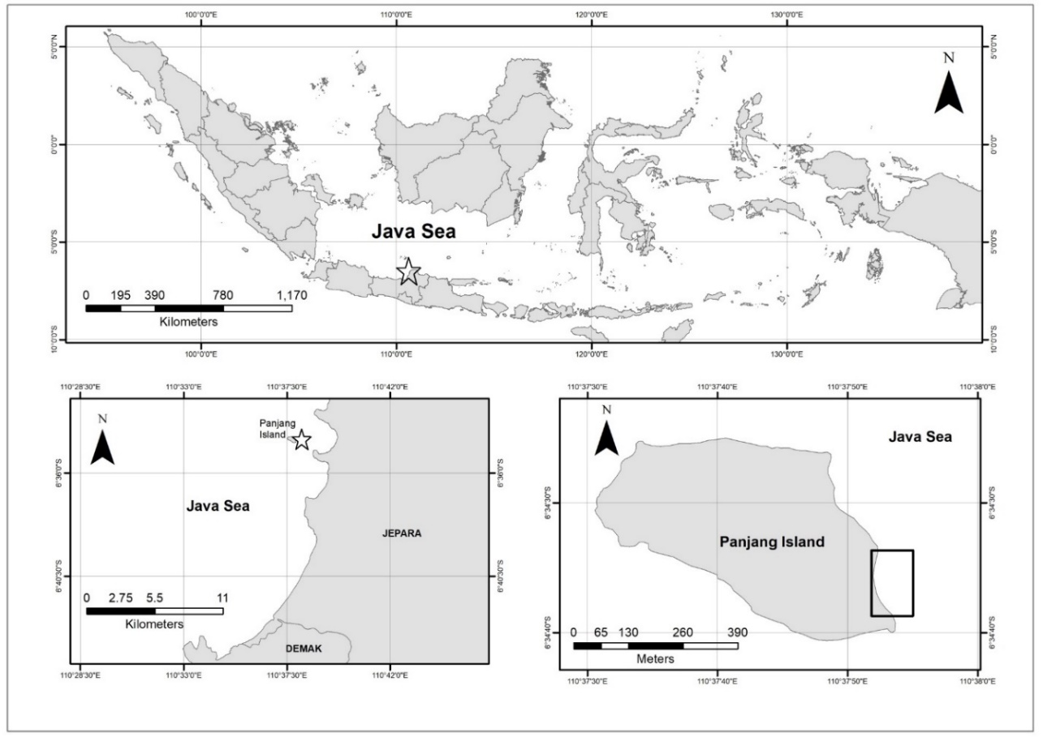
Figure 1. Study site of coral recruitment on multilevel Artificial Patch Reef at Panjang Island, Central Java (Java Sea)

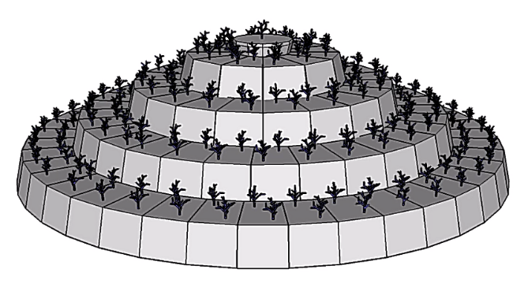
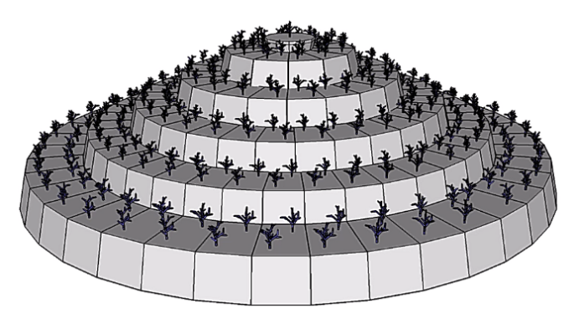
b
a
Figure 2. Multilevel substrate of Artificial Patch Reef (APR) deployed in Panjang Island, Central Java made by concrete block which combined in coral transplantation for coral recruitment study (a. APR#1 and #2; b. APR#4, APR#5, APR#7 and APR#12; Munasik et al., 2020)

Table 1. Density of coral recruits (recruits/m²) during the biweekly observation of short-term recruitment on the multilevel substrate of APR#4 and APR#12, January-April 2019
Genera | 18 Jan | 01 Feb | 21 Feb | 08 Mar | 24 Mar | 11 Apr
Oulastrea | 18.3 ± 2.7 | 19.5 ± 2.1 | 19.5 ± 2.1 | 20.6 ± 1.9 | 21.3 ± 2.5 | 22.1 ± 3.0
Porites | 5.1 ± 0.6 | 5.2 ± 1.0 | 5.3 ± 0.8 | 5.8 ± 1.1 | 6.4 ± 0.7 | 7.3 ± 0.5
Goniastrea | 1.2 ± 0.6 | 1.4 ± 0.7 | 1.4 ± 0.7 | 1.8 ± 0.5 | 2.1 ± 0.7 | 2.2 ± 0.7
Pocillopora | 1.2 ± 0.3 | 1.3 ± 0.1 | 1.4 ± 0.2 | 1.7 ± 0.1 | 1.8 ± 0.1 | 2.0 ± 0.2
Note: All results are expressed as mean ± SD.

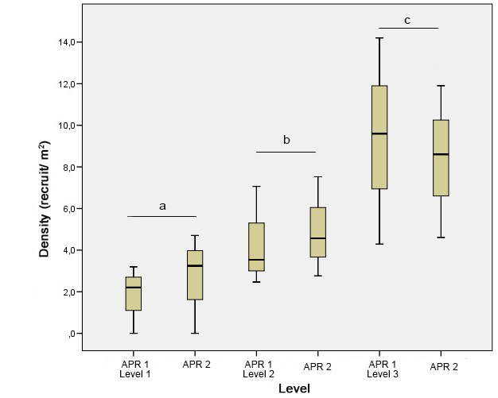

Figure 3. Comparison of coral recruit density in different level of APR for observation period 2017-2019, APR#1 deployed on June 2015and APR#2 deployed on September 2015 (only level 1, 2 and 3 were analyzed cause of coral juveniles on level 4 and 5 of APR#2 were absent)

Figure 4. Average Density (±SD) of coral juveniles in different level of APR for observation period 2017-2019

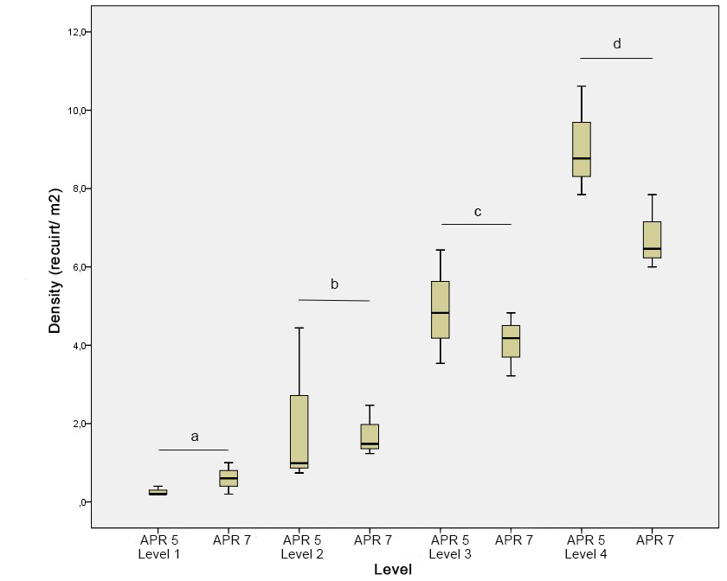

Figure 5. Comparison of coral recruit density in different level of APR for observation period 2018-2019 (APR#5 and APR#7 deployed on December 2016)

Figure 6. Density of coral juveniles (recruits/m²) in different of generic composition on multilevel substrate of APR#1 deployed on June 2015

Figure 7. Density of coral juveniles (recruits/m²) in different of generic composition on multilevel of APR#2 deployed on September 2015

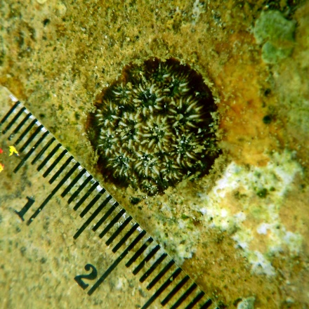  a | 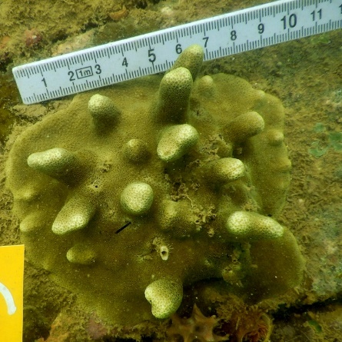  b | 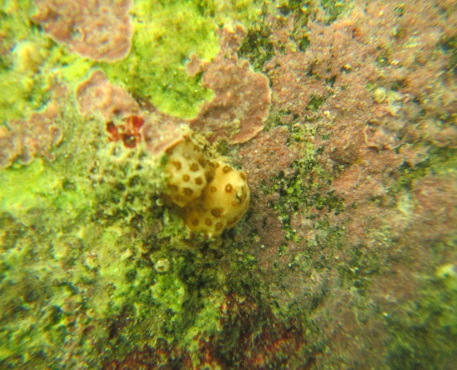  c
Figure 8. Coral recruits were observed on the surface of multilevel substrate of APR (a. Dominant coral recruits of Oulastrea crispata, b. The second dominant coral Porites cylindrica, and c. Pocillopora competes for space with sponges)

Figure 9. Size frequency distribution of Oulastrea crispata on different level of APR#1 observed in 2019

