SHORELINE CHANGE DYNAMICS USING DIGITAL SHORELINE ANALYSIS IN CEMARA BESAR ISLAND
DINAMIKA PERUBAHAN GARIS PANTAI MENGGUNAKAN ANALISIS GARIS PANTAI SECARA DIGITAL DI PULAU CEMARA BESAR

Muhammad Ramdhan¹, Yulius¹ and Nur Kholik K P ²

¹Researcher in Marine Research Center, BRSDM – KKP
²Oseanography Student in Universitas Dipenogoro, Semarang
Jln. Pasir Putih 1 Ancol Jakarta; Telp/fax : +62 21 64711583
Email :m.ramdhan@kkp.go,id

Abstract
This paper will describe a study to find out the shoreline changes that occurred on Cemara Besar Island along with the accretion and abrasion. Data taken from the images was obtained through google earth as a result of radiometry and geometry correction from Landsat satellites in the last 5 years. Wind data is obtained from ecmwf interm every season for 5 years. Analysis of shoreline changes was carried out using the DSAS (Digital Shoreline Analysis) method and analyzed by wind and sea wave factors in each season. The results of the analysis obtained LRR and EPR values for 5 years, the extent of changes in island land mass, the value of Hs and Ts from the results of wave forecasting using wind data. To simplify the analysis, Cemara Besar Island is divided into 9 segments based on variations in LRR values. The results show that in general Cemara Besar Island have very high accretion in segments A, B and E with an average of 3.61 m and very high abrasion occurred in segment F with an average of -1.01 m. Abrasion occurs with the greatest speed of change in segment A with an average of 4.64 m/year and the largest accretion rate in segment F with an average of -1.21791 m/year. Analysis of oceanographic factors through wave forecasting shows that in the west and transition I season, waves occur with Hs 1.21 m, greater than the eastern season and transition II season with Hs 0.91 m. wind direction from north dominant direction 377.50 in west season and transition I, and from east direction 67,25 in east season and transition I season. Direction of wind blowing influences wave propagation and direction of wave coming towards shore which affects sediment transport which produces accretion and abrasion on the Cemara Besar Island.
Key Words: DSAS, Shoreline dynamics, Cemara Besar Island

Introduction
The beach is a complex ecosystem. Complexity is characterized by natural and non-biological natural resources^{[1][2]}. From the perspective of interaction, the beach becomes a zone of interaction between land, sea and air which has the ability to adjust to maintain natural balance. The ability of the coast to respond to the process of oceanographic dynamics causes the coast to be a dynamic area^{[3][4]}. Beaches consist of many natural process dynamics that occur, both from sea to land and vice versa. Some natural processes that occur such as abrasion, accretion, sediment transport pollution and environmental pollution. While the processes formed due to human activities such as the process of development and management of coastal areas. Changes in beach profile occur quickly or slowly depending on the beach topography, hydro-oceanographic processes, climatic conditions, coastal vegetation, and sediment transport that occurs^{[3][5] [6]}.
Beaches are included in coastal areas that are still influenced by tidal phenomena. The beach has the ability to absorb ocean wave energy that radiates to the coast. Beach functions as a buffer can protect sea cliffs, settlements on the coast. Wave propagation carries sediment intake within a certain period of time. This process causes pressure on the coastal area, which is usually characterized by the presence of abrasion and accretion on a beach^{[7][8]} .
The coastline is defined as the location of a meeting between land and sea which has high dynamics of natural processes. The shape and location of the coastline can constantly change based on conditions between land and sea over a period of time^{[6][9][10][11]}. Factors in geological strength and extreme phenomena can have an impact on shoreline changes^{[11][12]}.
Sea waves are one of the factors that influence changes in the coastline. Waves that radiate to the coast can generate longshore currents that carry sediments to move. Components of the wave that affect them include the coming angle, duration, and wave energy, where wave energy is proportional to the wave height^{[3][13]}.
The large pine island has a fairly wide sand area^{[14]}. Plains of the island are overgrown with pine trees with little mangrove. Sediment cover on the majority island of gravel mud with distribution to Karimun Island and Menjangan Island. Furthermore sediment in the form of alluvium is typically composed of crust, gravel, sand, clay, coral fragments, and pumice^{[15]}.
Cemara Island is a large island under the authority of the use and management of the Ministry of Maritime Affairs and Fisheries. While the waters of the Big Pine Island are included in the management area of ​​Karimun Jawa National Park^{[16]}. Further explained that one component of tourism development is geographical conditions including geology, topography, and seasons. Likewise, geographical conditions are a factor in the evaluation of tourism resources. Thus, the phenomenon of shoreline change needs to be identified. The importance of this is that tourism areas require physical needs such as infrastructure that need comprehensive spatial planning.
So as a contribution effort in the arrangement of coastal spaces, and small islands, this study was carried out to see the changes in the coastline that occurred during the period 2013 - 2018 and to find out the level of abrasion and accretion that occurred. In addition, this study also aimed to see the extent of land changes the island caused by abrasion and accretion. Thus it can be analyzed the causes and chronology of the emergence of abrasion and accretion along the coast of the Cemara Besar Island.
Methodology
The study was carried out on the Big Cemara Island which is included in the Karimun Jawa Islands, Jepara Regency. The study area of shoreline change is at 110.383087°E - 110.365044°E and 5.801994°S - 5.811045°S. Analysis of shoreline changes in this study was related to sea wave conditions in the waters around Cemara Besar Island as shown in Figure 1 flowchart. Satellite data and wind data temporal range was 5 years (2013 - 2015).
  - Shoreline changes
This study use satellite image data, and wind data. The satellite image used is Landsat imagery produced by Google Earth Pro with the acquisition date of March 13, 2013, October 29, 2016, and February 21, 2018. The image of Google Earth Pro was chosen because it contain Landsat imagery and other multi spatial resolution satellite imagery. Landsat has advantages to cover a wide geographical area and has several bands with spectrum values ​​that are suitable for analysis of shoreline changes^{[17]}. The selection of the acquisition date is based on tidal calculations with reference to the water level which is the same as the Mean High Water Level (MHWL).

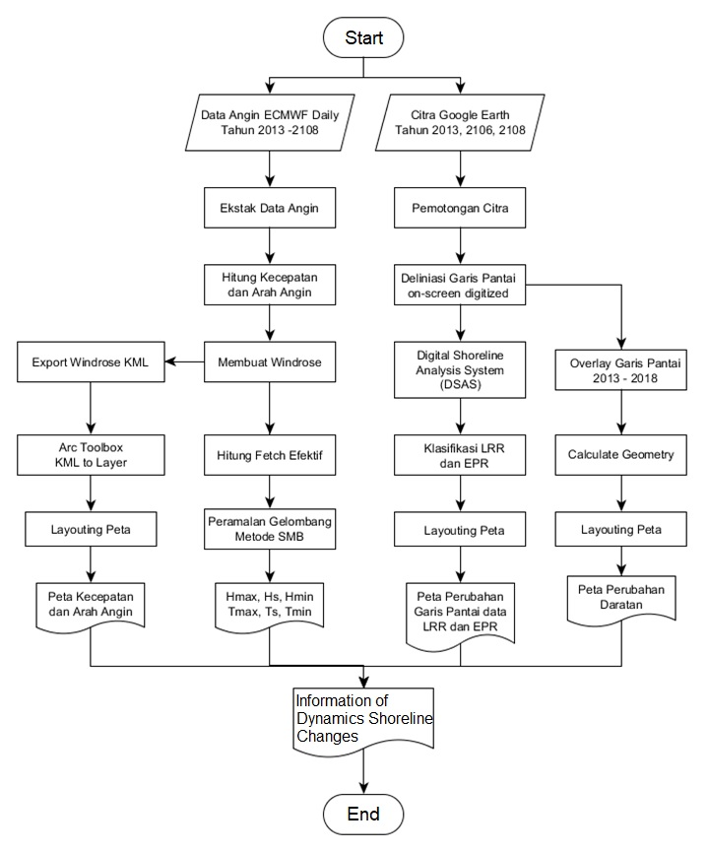
Figure 1. Flowchart of the study
Coastline information is obtained by delineation carried out on-screen digitized considering the narrow location of the digitized research is done by identifying differences in line boundaries between dry and wet areas^{[18][19]}. Analysis of changes in area was carried out overlaying island mainland polygons from all years. This method is done to find out the extent of differences that are different from abrasion and accretion^{[20]}. Whereas to find out the level of abrasion and accretion, transects that are perpendicular to the deepest coastline are used using the Digital Shoreline Analysis System (DSAS) method^{[18][21] [22]}.
The calculation on DSAS is based on the distance between the baseline and the entire coastline. DSAS consists of several transects that can be determined according to the beach conditions. DSAS automatically calculates statistical data for Shoreline Change Envelope (SCE), Net Shoreline Movement (NSM), End Point Rate (EPR), Linear Regression Rate (LRR), Weighted Linear regression (WLR), and Least Median of Squares (LMS) . This study uses statistical data used, namely NSM, EPR, and LRR with 1 meter transect distance and 120 meter transect distance. Data on EPR and LRR are then classified into 4 classes for abrasion and accretion respectively. Calculation of classification is based on standard deviation and average of LRR and EPR.
The statistical results and classification of EPR and LRR values ​​are displayed in maps prepared using ArcGIS 10.5 software. While NSM data is used to see the distance of accretion and abrasion changes that occur along the transect.

  - Wave Generation
Daily speed and wind direction are obtained from the ecmwf.int website. Wind direction and velocity data that have been obtained is done for wave forecasting using the SMB (Svedrup munk Bretschneider) method referring to CERC, 1984^{[5]}. Stages of ocean wave forecasting consist of wind data filtering, determination of effective fetch length, calculation of period and height of ocean waves. data is carried out until the height and wave period are obtained according to the equation expressed in:
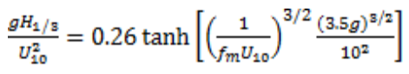
(1)
Where H1 / 3: significant wave height 33.3% of wave population, U10: wind speed at an altitude of 10 meters above sea level (m / s), fm: peak frequency in the wave spectrum. However, fm cannot be determined, but is derived from the inverse count of significant H.
Wind data is at an altitude of 10 meters, so it needs to be corrected by correcting the equation^{[23]} :
$U_{z}=U_{10}{\left(\frac{z}{10}\right)}^{α}$ (2)
Where Uz: wind speed is measured from the height of the station location (m / s), U10: wind speed at an altitude of 10 meters (m.s), and z is the height of the surface (m), and α: power index of 0.12.
Wind data consists of data in March, June, September and December which are expected to represent 4 seasons in Indonesia namely West Season, Transition Season 1, East Season and Transition Season II^{[26]} . Determining the point of wind location is based on the location of the closest sample point to the Cemara Besar Island, which is at 110.3750º E; 5.8750º S.
Determination of effective length fetch is based on the dominant direction of wind blowing on all four seasons. Then a straight line is drawn for a maximum of 200 km. When crashing into an island or land, the fetch length is stopped to land / island. The fetch line is made of 15 lines as wide as 840 every 60 both positive and negative directions from the dominant wind direction. So that there will be effective long fetch for one season through the equations used by Resio, Bratos and Thompson, 2003; Etemad-Shahidi, Kazeminezhad and Mousavi, 2009^{[23][24]} :
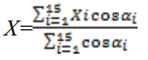
(3)
Where X: effective fetch length (m), α: angle from the dominant direction (multiples of 60).
Hs height can be determined if it is in fetch-limited condition. This condition if duration llimited is greater than tmin. Then the equation used to get Hs is written in^{[5]} :
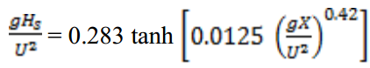
(4)
Where Hs: significant wave height (m), U: corrected wind speed (m / s), and g: gravitational acceleration (9.81 m / s²).

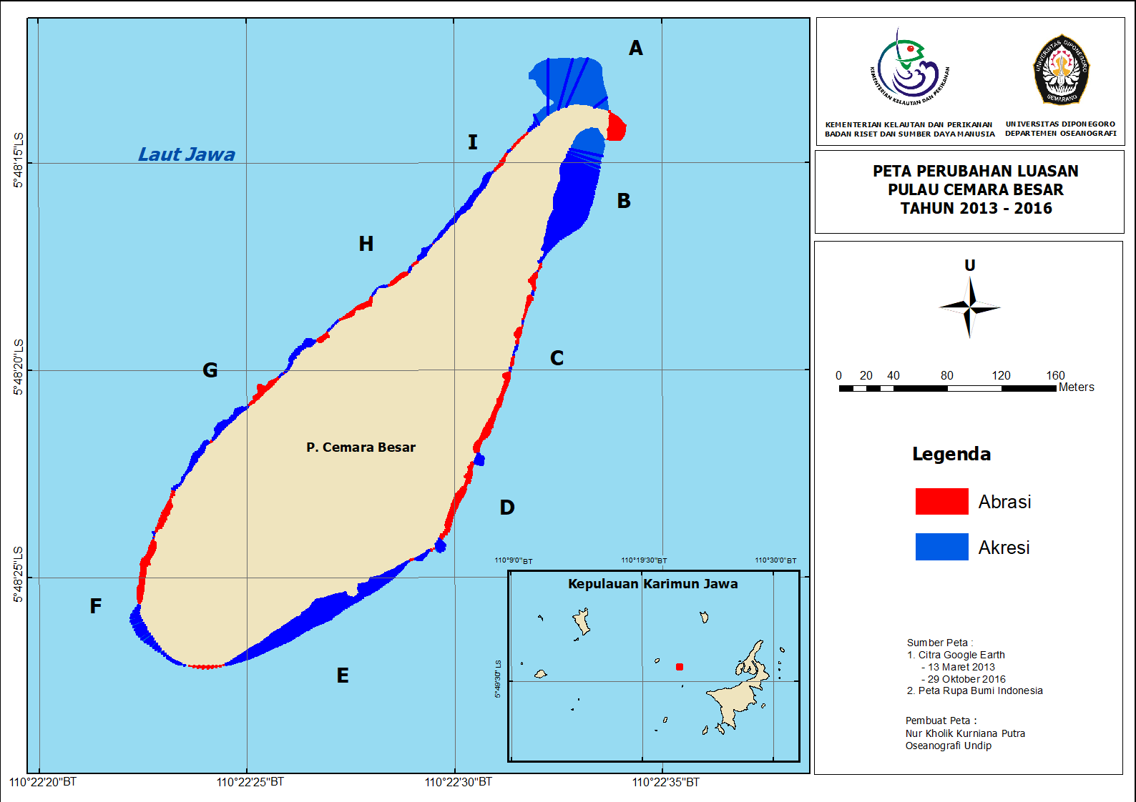
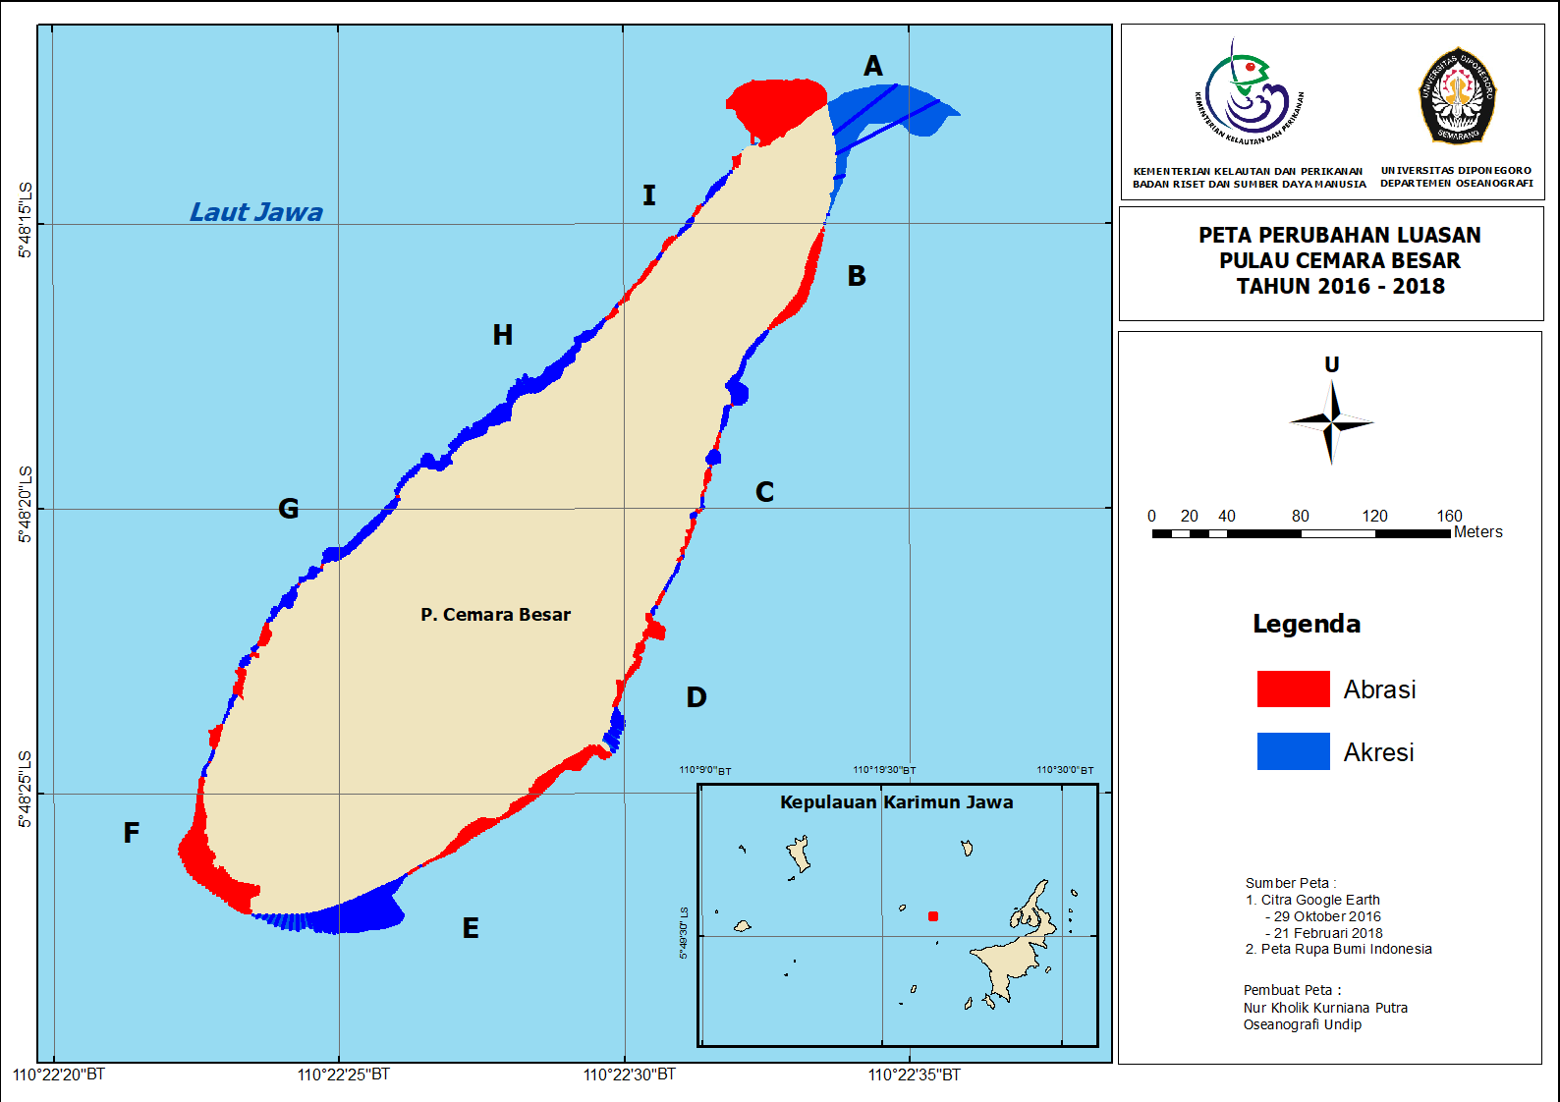
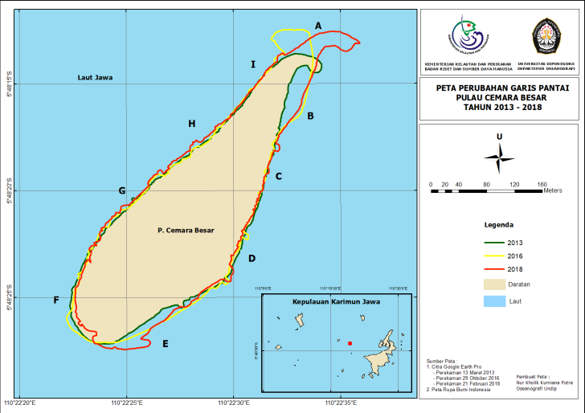
a)
b)
Figure 3. Area Changesin Cemara Besar Island : a) 2013 – 2016; b) 2016 - 2018
Figure 2. Shorelines Changes in Cemara Besar Island in 2013 - 2108
Result and Discussion
  - Area Changes
Analysis of changes in the land area of ​​the island to see land changes in a certain period. The result of image delineation shows a change in the coastline of Cemara Besar Island in Figure 2. Changing coastlines occurred massively in the period 2013 - 2016 (Table 1). Akresi 2013 - 2016 is characterized by the presence of new land in segments A and B (Figure 3). Whereas changes from 2016 - 2018 appear to be only the movement of sediments from one place to another. From the map (Figure 3) it can be traced to the phenomenon of abrasion-accretion that occurs along the coast of Cemara Besar Island.
The first review, 2013 was the land of light brown, then experienced abrasion in the period 2013-2016 covering an area of ​​1230 m2. The abrasion that occurs is small, it appears abrasion in the B, C, D, F, G and H. segments in the same period the big Cemara Island is like getting a lot of sediment supply, so that new land formed through accretion from 2013 to 2016 is marked with green eluas 6226 , 484 m2. This new land in the next period was abrased and moved to land in blue. This braking occurred in the period 2016 - 2018 covering an area of ​​322,613 m2. The length of the braking occurred in segment F. The 2016 - 2018 accretion sediment supply was thought to originate from the mainland. of course it will have an impact on the ecosystem, and space planning.
Table 1. Abrasion-accretion Area in Cemara Besar Island
Condition | Area (m²)
Accretion 2016 - 2018 | 3954.219
Abbration 2016 - 2018 | 3229.613
Accretion 2013 - 2016 | 6226.484
Abbration 2013 - 2016 | 1230.000

  - Abbration and Accretion
Abrasion and accretion along the coast of Cemara Island are classified into 8 classes. Basic classification is based on standard deviation values with a middle value of 0, and abrasion ranges if> 0 and accretion <0. So the DSAS analysis shows a variety of abrasion and accretion levels in each segment.
Based on (Figure 4) based on the LRR parameter shows that very high abrasion occurs in the F segment marked with bright red. Whereas moderate to weak abrasion is in segments D and C. The same condition is shown by the EPR parameter that in segments F, D and C shows the existence of abrasion. The red the color of the transect, the smaller the EPR means the speed of the abrasion rate in meters / year is getting bigger.
The abrasion range is shown in Graph 2 that at F segment maximum LRR and EPR values ​​are in the abrasion category. So that the average value of the F segment is accretion at -1.006 for LRR and -1.218 m / year for EPR. While segments D and C the maximum value is in the accretion category, but the average value indicates abrasion. In segment D there was an abrasion with an average of -0.663 for LRR and -0.750 m / year for EPR, while segment C with a narrower range had an abrasion average of -0.281 for LRR and -0.216 m / year for EPR.
The abrasion phenomenon will be followed by accretion on the other parts of the beach. The opposite is also true, meaning that abrasion and accretion are interrelated process dynamics in the process of natural balancing ^{[12]}.
The accretion process is more dominant than abrasion along the coast of Cemara Island. In terms of Graph 1, the positive average values ​​for LRR and EPR are 6 segments, namely: segments A, B, E, G, H, I. The highest accretion is in segment A with an average value of 4,644 m / year for EPR and 4,931 for LRR. While the lowest accretion is in segment I with an average value of 0.290 m / year for EPR and 0.322 for LRR.
Based on Figure 4a) very high accretion occurs in segments A, B and E. While segments G, H, I experience moderate to weak accretion, with several high locations. However, different things shown in Figure 4b) based on EPR parameters show very accretion rates. height remains in segments A, B and E. while segments G, H, I have accretion rates that tend to be slow.
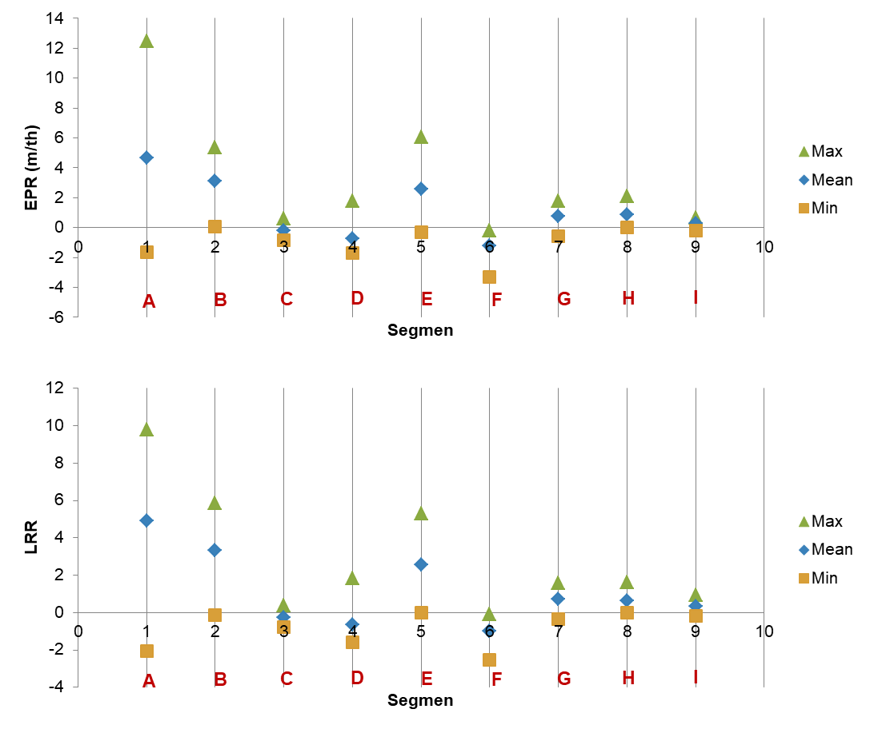
Accretion and abrasion along the coast have uniformity along the west coast, and uniform on the east coast. The west coast has a tendency to lower accretion rates with high abrasion rates. While on the east coast the accretion rate is very fast with a slow abrasion rate. this needs to be reviewed from the hydro-oceanographic aspects that work along the coast.
Graph 2 : a) Range of EPR (m/year) in all segment; b) Range of LRR in all segment
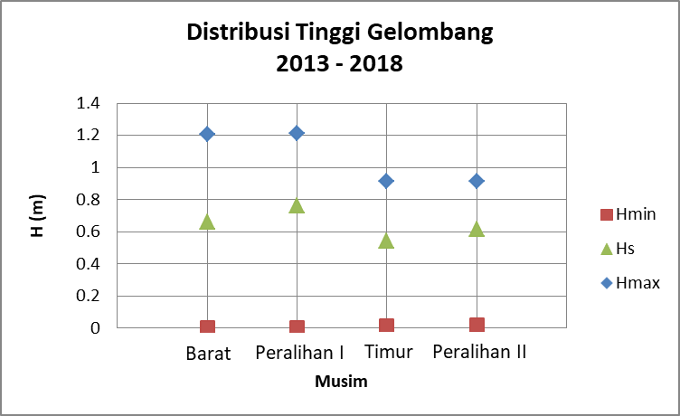
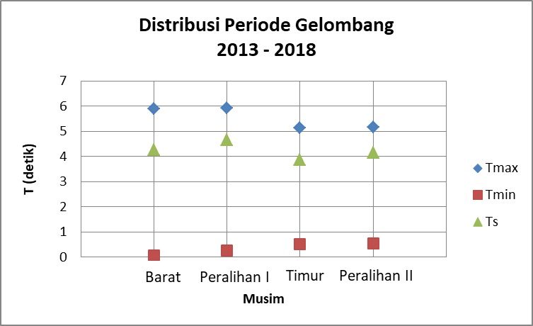
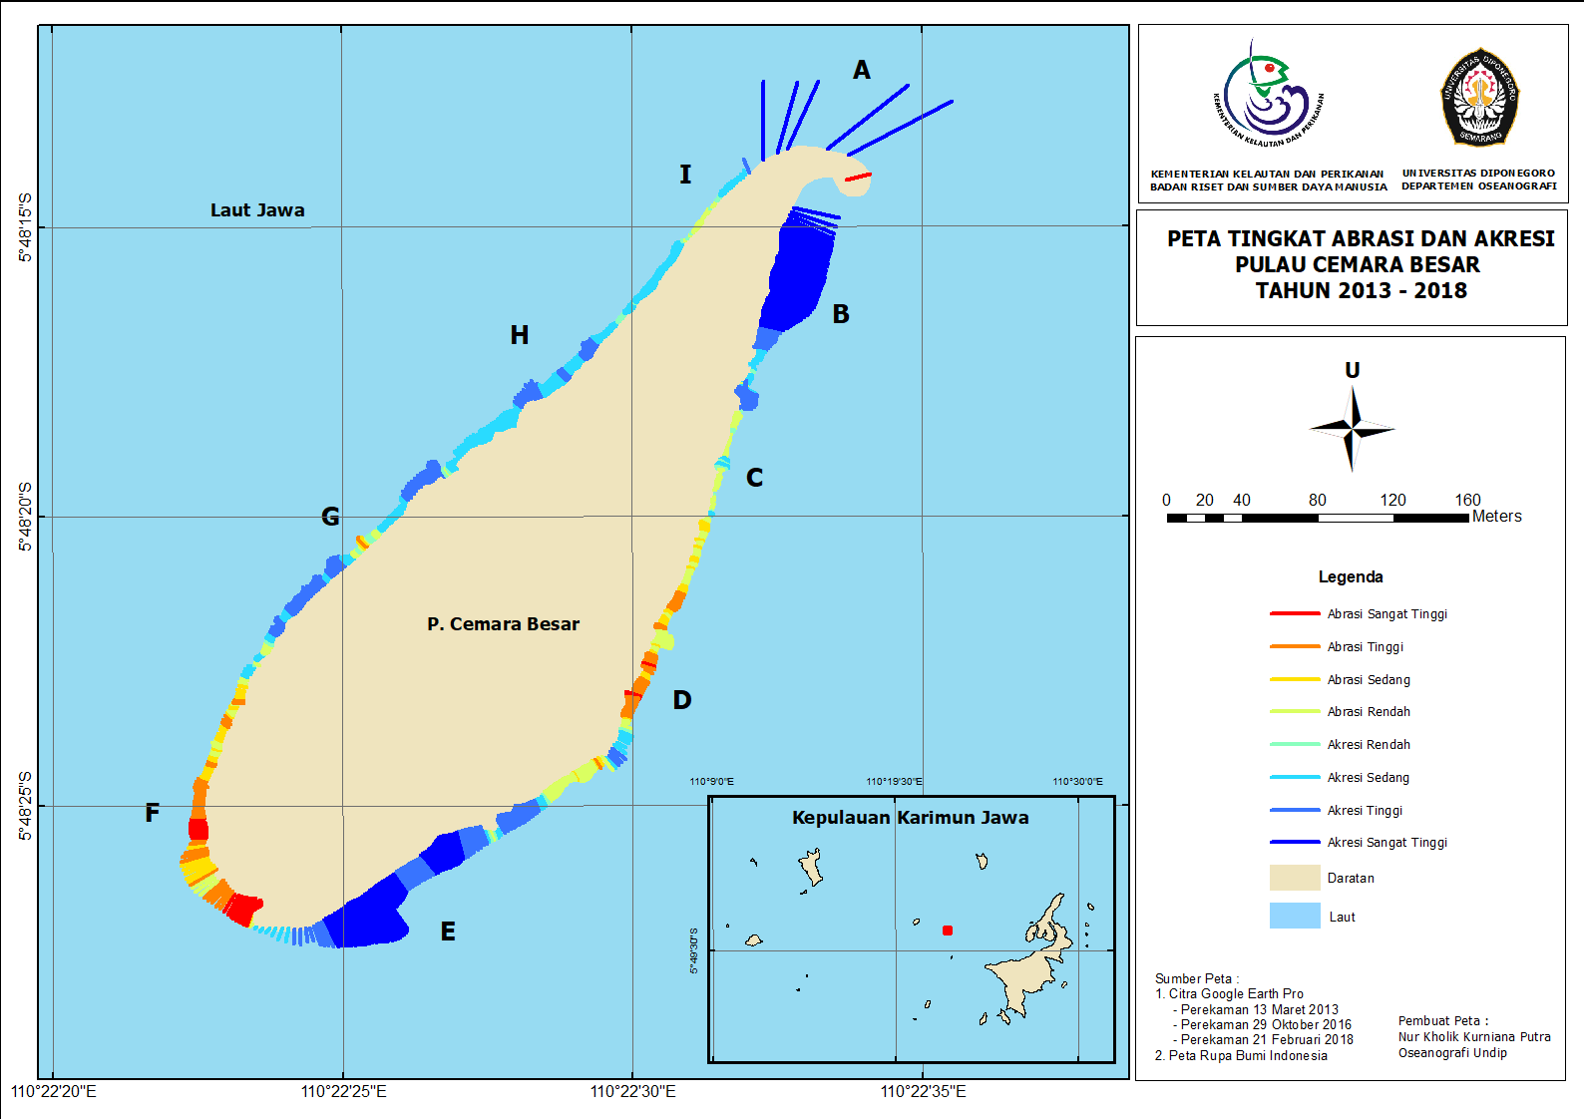
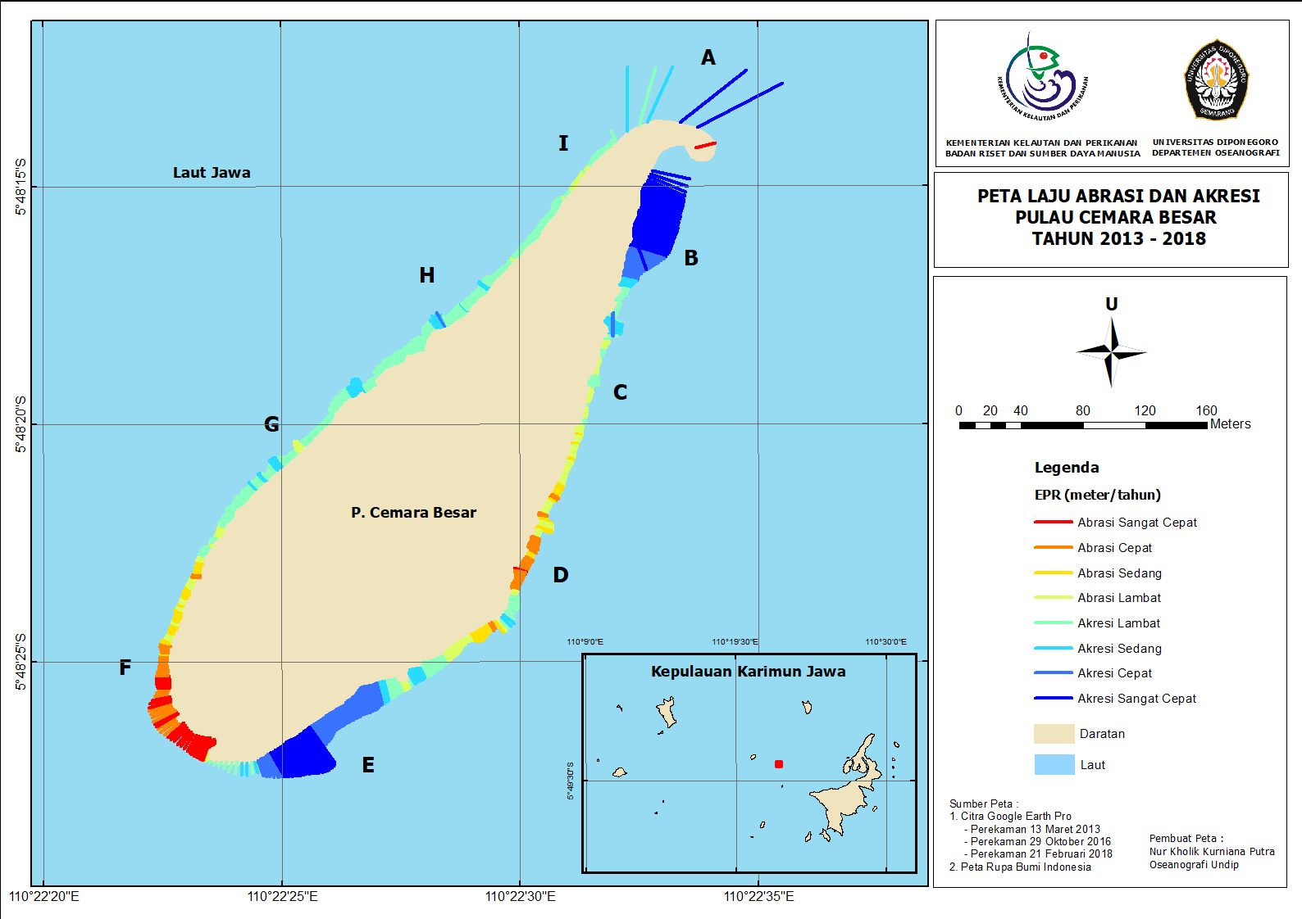
Figure 5 : a) Distribution of Wave Height H(m); b) Distribution of Wave Period T(second)
4a)
4b)
Figure 4 : 4a) Abbration and Accretion Value; 4b) Abbration and Accretion Rates.
  - Sea Wave
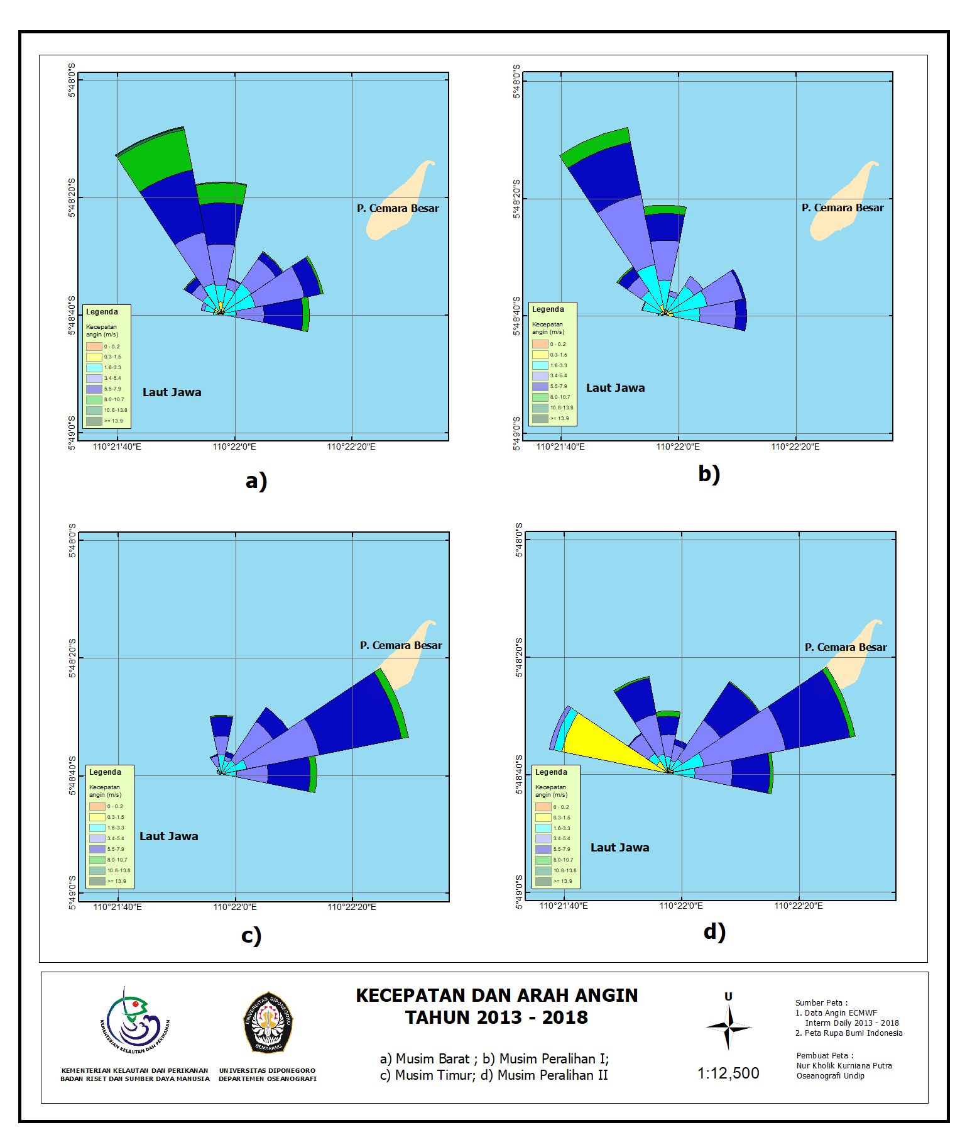
The condition of the sea waves that spread along the coast of Cemara Island is influenced by the wind. Wind conditions throughout 2013 - 2018 experience differences in direction and speed in each season such as. Based on Figure 5, it has the same dominant direction for the western season and transition I, which is blowing from 337.50, which is northward towards the northwest. Whereas for the eastern season and transition II blowing from the direction of 67,250 which is the northeast-east direction. The difference in wind direction in each season causes differences in the wave conditions that are generated.
Graph 5. Speed and direction of the Wind in all season
Based on wave forecasting using the SMB method, it is obtained high Hs and Ts periods for each season. Judging from Graph 2 shows that the height and wave period in the western season and transition I tend to be higher than the east and transition II.
Judging from the high distribution of Hs and the dominant direction of the wind, the large waves occur in the western season and the transition season I with propagation from the direction of 377.50. So that the west coast is directly affected by this large wave. transition I with relatively low Hs with the dominant direction of 67,250. This condition can show if the difference in accretion rates between the east and west coasts is due to differences in waves leading to the coast.
  - Sediment Rate
Sediment supply can be reviewed with 3 methods, namely measuring direct sediment discharge, image analysis, and using empirical formulas for sediment volume ^{[3]}. Based on descriptive analysis based on the empirical formula proposed by Ijima and Tang, 1967 as follows^{[25]}:

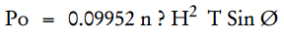
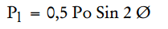
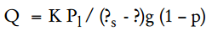

With Po is the energy of wave flux (newton-meter / second), H: wave height (m), T: wave height (s), ∅: wave coming angle, and ρ: water density of 1025 kg / m3. That the height and wave period are directly proportional to the energy of the wave flux found on the beach. Energy wave fluxes state the amount of energy received by the coast based on the incoming wave. Flux energy waves are also directly proportional to the rate of Q sediment volume (m3 / day). So that in this case, the height and wave period of the wave forecasting results can explain the differentiation in the conditions of the sediment volume rate between the west coast and the east coast of the Cemara Besar Island.

Viewed in Figure 4a shows that in segment F there is very high abrasion. This can be caused by large flux energy, especially during the western season and transition I. Sediment in the F segment moves to segment E and along G, H, I. However, it is not known for sure the sediment supply in segments G, H, I originates from segment F.

Different conditions occur on the east coast. As shown in Figure 4a that the east side coast experiences very high accretion in segments A, B, and E. This accretion can occur due to the relationship of sediment transport between the surrounding islands. It is marked by distance and connectivity between the islands. The Big Pine Island is closer to Karimun in the east which is actually a large island. This connectivity can answer the accretion level on the east side which is very high, as long as the sediment supply originates from Karimun Island at a rate that effective during the east and transition seasons II. This is in accordance with Gustiantini and Ilahude, 2016 in the map presented illustrating if Cemara Besar Island has the same sediment distribution as Karimun Island, which is muddy mud.

Conclussion
Analysis using the Digital Shoreline Analysis System was able to show the presence of abrasion and accretion along the coast of Cemara Besar Island from the changes in coastline that occurred. Changes in the island's largest land area in 2013 - 2016 due to accretion of 6226,483 m². The level of accretion is very high in segments A, B, and E as well as very high abrasion in segment F. The accretion and abrasion phenomenon is approached by the empirical formula of the volume of sediment, that accretion and abrasion are influenced by waves with different characteristics each season and similarity of sediments with nearest island island.
This study has disadvantages in terms of verification of field data. Thus it would be better if the coastline was verified with field data. In addition, an analysis of the sediment supply rate can be carried out directly either by measuring sediment discharge or by empirical formula with direct observation of the incoming wave and verification of wave forecasting data.

Acknowledgments

Authors wishing to acknowledge assistance and encouragement from all colleagues, special work by technical staff and financial support from Ministry of marine and fisheries, Republic of Indonesia.
Also from Dipenogoro University.

References:

[1] Beatley, T., Brower, D. and Schwab, A. K. 2002 An introduction to coastal zone management. Island Press.
[2] Aedla, R., Dwarakish, G. S. and Reddy, D. V. 2015 ‘Automatic Shoreline Detection and Change Detection Analysis of Netravati-GurpurRivermouth Using Histogram Equalization and Adaptive Thresholding Techniques’, Aquatic Procedia, 4, pp. 563–570. doi: https://doi.org/10.1016/j.aqpro.2015.02.073.
[3] Triatmodjo, B. 1999 ‘Teknik pantai’, Beta Offset, Yogyakarta, 397.
[4] Hidayat, N. 2012 ‘Kajian Hidro-Oceanografi untuk deteksi proses-proses fisik di pantai’, Smartek. Tadulako University, 3(2).
[5] CERC, S. P. M. 1984 ‘Coastal Eng. Research Centre’, US Army Corps of Eng., Washington.
[6] Guariglia, A. et al. 2006 ‘A multisource approach for coastline mapping and identification of shoreline changes’, Annals of geophysics, 49(1).
[7] Febriansyah, I., DS, A. A. and Helmi, M. 2012 ‘Kajian kerentanan pantai di pesisir Kabupaten Cilacap, Jawa Tengah’, Journal of Oceanography, 1(2), pp. 139–148.
[8] Siswanto, A. D., Pratikto, W. A. and Suntoyo, S. 2012 ‘Analisa Stabilitas Garis Pantai di Kabupaten Bangkalan’, ILMU KELAUTAN: Indonesian Journal of Marine Sciences, 15(4), pp. 221–230.
[9] Alesheikh, A. A., Ghorbanali, A. and Nouri, N. 2007 ‘Coastline change detection using remote sensing’, International Journal of Environmental Science & Technology. Springer, 4(1), pp. 61–66.
[10] Tran, T. Van and Trinh, T. B. 2009 ‘Application of remote sensing for shoreline change detection in Cuu Long estuary’. VNU.
[11] Addo, K. A., Jayson-Quashigah, P. N. and Kufogbe, K. S. 2011 ‘Quantitative analysis of shoreline change using medium resolution satellite imagery in Keta, Ghana’, Marine Science, 1(1), pp. 1–9..
[12] Boak, E. H. and Turner, I. L. 2005 ‘Shoreline definition and detection: a review’, Journal of coastal research, pp. 688–703.
[13] Hidayat, J. J., Yusuf, M. and Indrayanti, E. 2013 ‘Dinamika Penjalaran Gelombang Menggunakan Model CMS-Wave Di Pulau Parang Kepulauan Karimunjawa’, Journal of Oceanography, 2(3), pp. 255–264..
[14] Hartati, R. and Ambariyanto, A. 2005 ‘Identifikasi Sand Dollar dan Karakteristik Habitatnya di Pulau Cemara Besar, Kepulauan Karimunjawa Jepara’, ILMU KELAUTAN: Indonesian Journal of Marine Sciences, 10(1), pp. 1–10.
[15] Gustiantini, L. and Ilahude, D. 2016 ‘Foraminifera Bentik Dalam Sedimen Sebagai Indikator Kondisi Lingkungan Terumbu Karang Di Perairan Pulau Cemara Besar Dan Cemara Kecil Kepulauan Karimunjawa Jawa Tengah’, Jurnal Geologi Kelautan, 10(1), pp. 35–38.
[16] Umardiono, A. 2011 ‘Pengembangan Obyek Wisata Taman Nasional Laut Kepulauan Karimunjawa’, Surabaya: Universitas Airlangga.
[17] Miller, H. M. et al. 2011 The users, uses, and value of Landsat and other moderate-resolution satellite imagery in the United States-Executive report. US Department of the Interior, Geological Survey.
[18] Esmail, M., Mahmod, W. E. and Fath, H. 2019 ‘Assessment and prediction of shoreline change using multi-temporal satellite images and statistics: Case study of Damietta coast, Egypt’, Applied Ocean Research, 82, pp. 274–282. doi: https://doi.org/10.1016/j.apor.2018.11.009.

[19] G, V. et al. 2019 ‘Monitoring of Chilika Lake mouth dynamics and quantifying rate of shoreline change using 30 m multi-temporal Landsat data’, Data in Brief, 22, pp. 595–600. doi: https://doi.org/10.1016/j.dib.2018.12.082.
[20] Ozturk, D. and Sesli, F. A. 2015 ‘Shoreline change analysis of the Kizilirmak Lagoon Series’, Ocean & Coastal Management. Elsevier, 118, pp. 290–308.
[21] Gibson, G. R. 2006 An Analysis of Shoreline Change at Little Lagoon, Alabama. VIRGINIA POLYTECHNIC INST AND STATE UNIV BLACKSBURG DEPT OF GEOGRAPHY.
[22] Salmon, C., Duvat, V. K. E. and Laurent, V. 2019 ‘Human- and climate-driven shoreline changes on a remote mountainous tropical Pacific Island: Tubuai, French Polynesia’, Anthropocene, 25, p. 100191. doi: https://doi.org/10.1016/j.ancene.2019.100191.
[23] Resio, D. T., Bratos, S. M. and Thompson, E. F. 2003 ‘Meteorology and Wave Climate, Chapter II-2’, Coastal Engineering Manual. US Army Corps of Engineers, Washington DC, p. 72.
[24] Etemad-Shahidi, A., Kazeminezhad, M. H. and Mousavi, S. J. 2009 ‘On the prediction of wave parameters using simplified methods’, Journal of Coastal Research. JSTOR, pp. 505–509.
[25] Ijima, T. and Tang, F. L. W. 1967 ‘Numerical calculation of wind waves in shallow water’, in Coastal Engineering 1966, pp. 38–49.
[26] Hutabarat, S. and Evans, S. M. 1985 Pengantar Oseanografi. Penerbit Universitas Indonesia (UI-Press).

